*WetQual* GUI

User Manual

Auburn University

July 2019

*WetQual* GUI

User Manual

Sabahattin Isik1, Mehdi Rezaeianzadeh2, Latif Kalin1, Mohamed M. Hantush3

1 Auburn University, School of Forestry and Wildlife, Auburn University, AL 36849.

2 NOAA National Water Center, Tuscaloosa, AL 35401.

3 U.S.EPA National Risk Management Research Laboratory, Cincinnati, OH 45268.

Auburn University

July 2019

**ACKNOWLEDGEMENTS**

The U.S. Environmental Protection Agency through its Office of Research and Development funded and managed the research described here under EPA Contract #EP-C-15-010. The user manual and the software it supports are not necessarily endorsed by or represent policies of the U.S. Environmental Protection Agency.

Table of Contents

Section 1: Introduction 3

Section 2: Installing the GUI 4

2.1 Minimum System Requirements 4

2.1.1 Hardware requirement: 4

2.1.2 Software requirement: 4

2.2 MATLAB Runtime installation 5

2.3 GUI Installation 8

2.4 Structure of the Installation Folder 10

2.5 Preparing Input Files for GUI 13

Section 3: Getting Started with GUI 15

3.1 GUI Toolbar Items 15

3.2 Home 15

3.2.1 Open Project 16

3.2.2 New Project 17

3.2.3 Copying a Project 17

3.3 Input Files 18

3.3.1 Select Start Date 18

3.3.2 The Hydro-Climate Parameters 18

3.3.3 Flow Routing 23

3.3.3.1 Basic Inputs 24

3.3.3.2 Time Series Inputs 25

3.3.3.3 Bathymetry 28

3.3.3.4 Output 31

3.3.4 Basic Parameters 33

3.3.5 The Water Quality Inputs 36

3.3.6 Initial Concentrations: 36

3.3.7 Input Concentrations: 40

3.4 Model Parameters 41

3.4.1 Deterministic Model 42

3.4.2 Stochastic Model 43

3.5 Run 46

3.6 Post-processing 47

3.6.1 Visualize Output 47

3.6.2 Read Observed Data 51

3.6.3 Deterministic model performances 53

3.6.4 Uncertainty and Sensitivity Analysis 56

3.6.4.1 Uncertainty Analysis with GLUE: 57

3.6.4.2 Sensitivity Analysis with GLUE 63

3.6.4.3 Uncertainty Analysis with BMCML 66

3.6.4.4 Posterior CDFs and PDFs 71

3.7 Forecasting/Validation 73

3.8 Help 79

References: 81

Appendix: Definitions for Input files, parameters and output files of *WetQual* 83

# Introduction

This Graphical User Interfaces (GUI) was developed for the Wetland Water Quality Model, *WetQual* (Hantush et al. 2013; Kalin et al. 2013; Sharifi et al. 2013). The process-based *WetQual* model simulates nitrogen (N), phosphorus (P), total suspended sediment (TSS) and carbon (C) cycles and their dynamics in wetlands. The model partitions a wetland into three basic compartments: (1) (free) water column, (2) wetland soil layer, which is further portioned into aerobic and anaerobic zones, and (3) plant biomass (Hantush et al., 2013). The model simulates oxygen dynamics and the impact of oxidizing and reducing conditions on nitrogen transformation and removal, and approximates phosphorus precipitation and releases into soluble forms under aerobic and anaerobic conditions, respectively. Processes in surface water and the bottom-active soil layer are described by a system of coupled ordinary differential equations (Hantush et al., 2013). The model runs on daily time scale, while the model internally divides the one-day time interval into a smaller time interval for numerical integration. See the Appendix for a short description of *WetQual* subroutines and a flowchart which explains the internal structures/steps and processes of the *WetQual* model.

The *WetQual* GUI enables users with a basic knowledge of hydrology and water quality to easily apply the *WetQual* model to their wetland sites and related projects. The processes-based *WetQual* model can simulate the hydrology as well as water quality including nitrogen, phosphorous, carbon and sediment cycles in natural and constructed wetlands. *WetQual* can be used in continuously flooded environments or in wetlands going through wetting and drying cycles. This GUI has been developed to handle the former type of wetlands. The GUI reads in input forcings (i.e., climate/weather, runoff and nutrient loading) and geometry table (i.e., depth-area-volume-outflow relationship) to calculate wetland outflow, reference depth of water in wetland, wetland surface area and volume of wetland surface water. The GUI allows the *WetQual* model to be run either in a deterministic or stochastic mode. In the stochastic mode, users need to select the probability distributions (uniform, log-normal or triangular) and relevant statistics for each model parameter. The GUI generates random parameter sets and performs Monte Carlo Simulations (MCS) to generate an ensemble of outputs. It provides an opportunity to visualize both deterministic and stochastic model outputs through a series of graphs. With the latter, users can visualize the time series of various *WetQual* outputs for a particular parameter set. Alternatively, GUI can also summarize the ensemble of model runs through prediction intervals. If observed data is available, the GUI can also perform Generalized Likelihood Uncertainty Estimation (GLUE) (Beven and Freer, 2001) and Bayesian Monte Carlo simulation and maximum likelihood estimation (BMCML) analyses where users can perform uncertainty analyses (Hantush and Chaudhary, 2014).

# Installing the GUI

## Minimum System Requirements

Hardware and software requirements are explained below.

### Hardware requirement:

* Personal computer using a Pentium IV processor or higher, which runs at 2.0 GHz or faster
* 4 GB RAM
* 700 MB free space on the hard drive for installation (including example project folder).
* Enough space on hard drive if MCS are going to be performed. For instance, 4 GB of additional free space on the hard drive is required in order to store the outputs of a run with 10,000 simulations for a 2-year run, to visualize the outputs and have a successful post-processing analyses. This is the most extreme case where the user has observed data for all the constituents. This is just an example of the required space to provide the user with an insight into the space requirement for *WetQual* GUI run and analyses.

### Software requirement:

* Windows operating system (Windows 7 or higher version).
* Microsoft .NET Framework 4.5.2 or higher version.
* MATLAB® Compiler Runtime R2017a (9.2) (see section 2.2 for its installation).

(Only needed for the Stochastic Model. If the user will not run any stochastic simulations, then there is no need to install this.)

## MATLAB Runtime installation

1. If MATLAB® 2017a or MATLAB® Compiler Runtime R2017a (9.2) is already installed on the computer, user can skip steps 2-5 below and move to GUI installation in section 2.3.
2. MATLAB® Compiler Runtime R2017a (9.2) is freely available on MATLAB® website ([MATLAB Compiler](https://www.mathworks.com/products/compiler/matlab-runtime.html))). User needs to download MATLAB® Compiler Runtime R2017a (9.2) software. User has to make sure that downloaded file name is “MCR_R2017a_win64_installer.exe”. User needs to double click the file to start the installation. During the installation, if any warning or permission requests shows up, user should select “Yes” or “Accept” to continue the installation. After Matlab Runtime installer extracts necessary files (Figure 2.1), user needs to click Next button to continue installation (Figure 2.2).

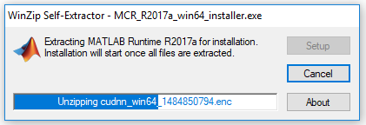

Figure 2.1

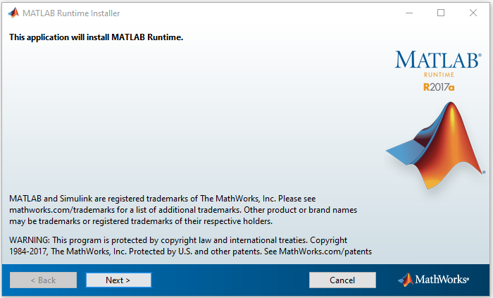

Figure 2.2

1. On the next window, user will be asked for MATLAB Runtime installation folder location. It is advised to keep the default folder (Figure 2.3). The license agreement that will appear on the next screen must be accepted to be able to install MATLAB® Compiler Runtime (Figure 2.4).

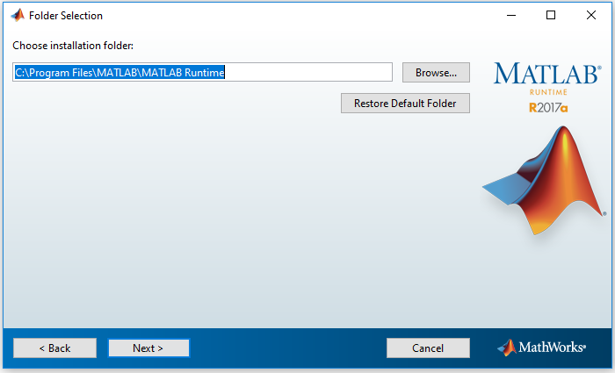

Figure 2.3

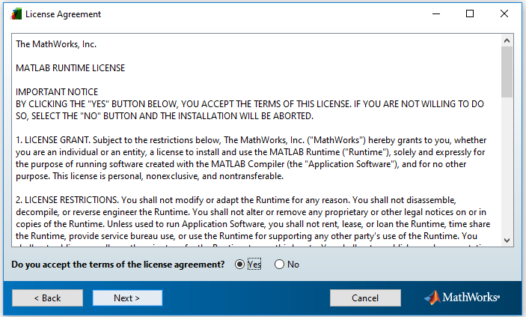

Figure 2.4

1. On the next window, when the user clicks “install” button, MATLAB Runtime installation will start, which can take several minutes depending on the computer speed (Figure 2.5 and Figure 2.6).

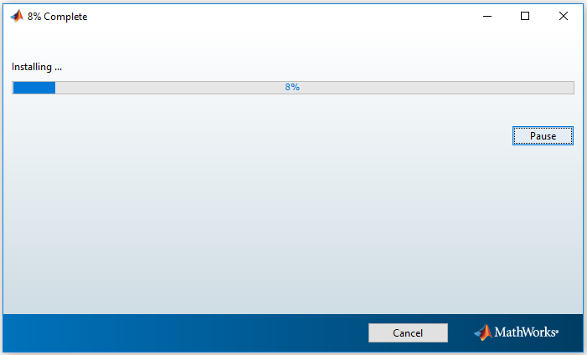

Figure 2.5

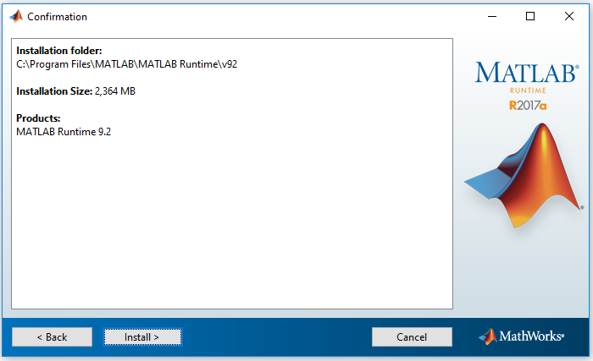

Figure 2.6

1. After the installation is successfully completed, click the Finish button to close the installation window (Figure 2.7).

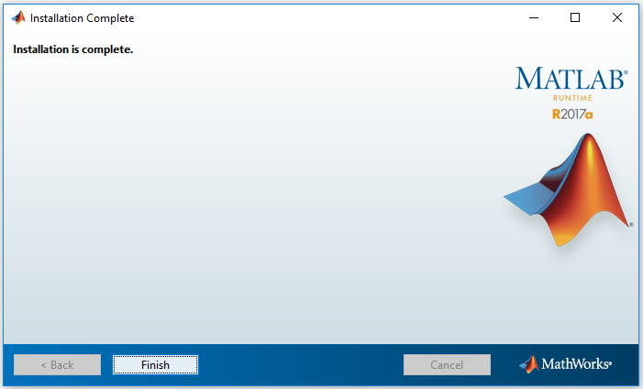

Figure 2.7

## GUI Installation

1. All the previous versions of the GUI must be uninstalled before installing the GUI (i.e., “WetQual_Install.msi”), using “**Add/Remove Programs in Programs and Features”** underControl Panel.
2. Double click the “WetQual_Install.msi” and the following dialog window will appear (Figure 2.8).

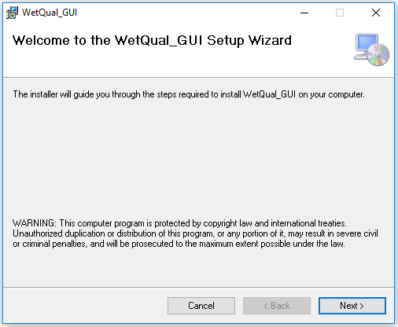

Figure 2.8

1. Click “**Next**”, then choose the installation folder. The default folder, “C:\WetQual\” is recommended (Figure 2.9).

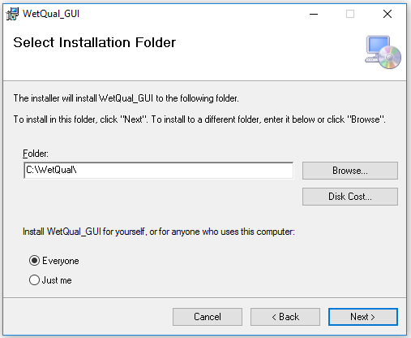

Figure 2.9

1. Click “**Next**” and the user will be asked to confirm installation as appears in the next dialog (Figure 2.10).

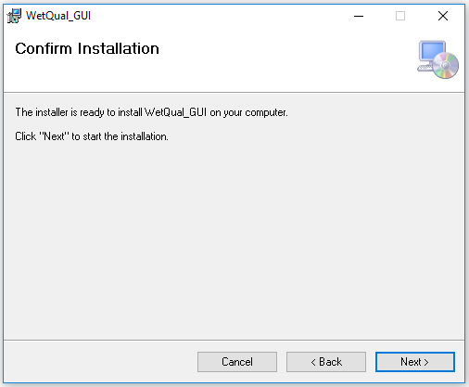

Figure 2.10

## Structure of the Installation Folder

Under the *WetQual* installation folder, the user will see two folders, named “InputOutput”, and “Observations” Figure 2.11).

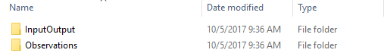

Figure 2.11

The “InputOutput” folder contains all the input files required for running *WetQual* listed below. When a new project is created, GUI will initially copy those files from the installation source files. User needs to update those with his/her own data. Only short descriptions of those files are given below. Detailed descriptions and formats of input/output files and all the model parameters are explained later in relevant sections. The GUI is interactive in reading necessary files and generating outputs.

* ***1_input_control.txt:***This file acts as a master (control) file for running *WetQual* in which the names of the required input files needs to be provided. The name of the file “*1_input_control.txt*” should not be changed. The GUI requires the following six input files as shown in Figure 2.12.

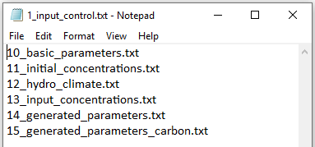

Figure 2.12

* ***10_basic_parameters.txt:***This input file provides basic parameters of *WetQual* (i.e., model parameters that are not calibrated or considered random during stochastic simulations).
* ***11_initial_concentration.txt:***Initial concentrations of nitrogen (N), phosphorus (P), total suspended sediment (TSS) and carbon (C) are provided to *WetQual* within this file.
* ***12_hydro_climate.txt:***The time series of hydro-climate input forcings are read and imported to *WetQual* with this file.
* ***13_input_concentrations.txt:***Time series of nutrient concentrations in incoming flow.
* ***14_generated_parameters.txt:***Some of the *WetQual* parameters related to N, P, TSS processes which are considered to be random in stochastic mode or need calibration in deterministic mode are provided in this file. Each row represents one parameter set. If the deterministic run is selected, there will be only one row of data. User does not need to prepare this file externally. GUI populates the parameter values from selected distributions. This is explained in more detail later.
* ***15_generated_parameters_carbon.txt:***This file is very similar to “*14_generated_parameters.txt*”. It has parameters related to carbon.

If a user has observed data for any of the model output variables (e.g. suspended sediment concentration in the water column, nitrate concentration in aerobic sediment layer, etc.), then the files containing such data should be copied under the “Observations” folder. See Table A. 6 in the Appendix for a list of *WetQual* output filenames. During “Post-processing”, the GUI looks for the exact same filename as a particular output in “Observations” folder. For example, if the user wants to see NO3w post-processing results, the file “108_obs_NO3w.txt” should be located under “Observations” folder (Figure 2.13). The formats of the observed files are explained in Section 3.6.2.

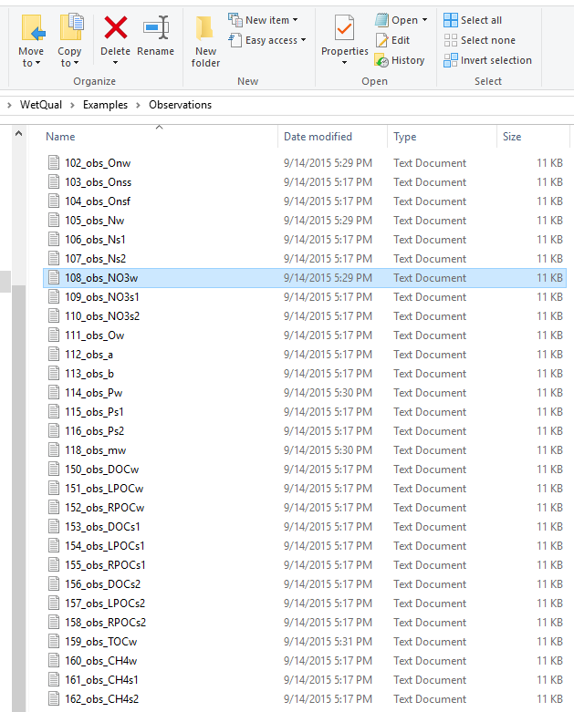

Figure 2.13

Users need to download the example data set separately because of its large size. The downloaded “Example Project” folder includes “Deterministic example” and “Stochastic example” folders. The “Example Project” folder can be copied anywhere on the hard drive.

The installation folder “WetQual_Install” will come with some other files which are automatically generated as complementary files of the GUI (Figure 2.14). A desktop icon is created to run *WetQual*, once installation is successfully completed.

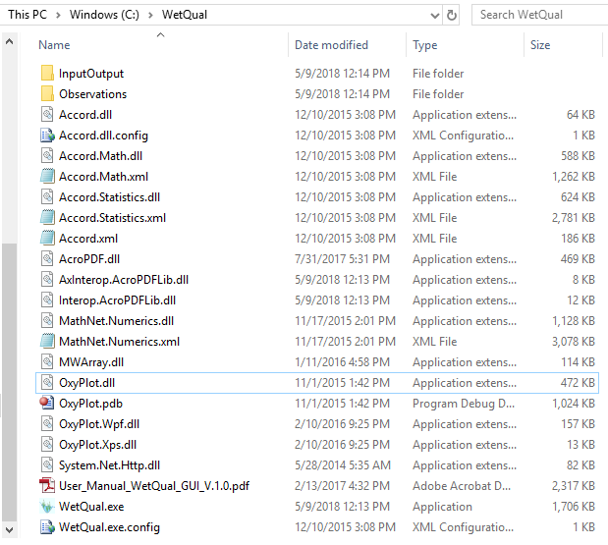

Figure 2.14

## Preparing Input Files for GUI

It is strongly recommended that the input files are prepared before getting started with the GUI. Sample input files are provided under the “Example Project” folder. An excel file named “Sample_InputFiles_for_WetQual.xls” which includes all necessary input files is also provided under the “Example Project” folder. User can find each sample input file in separate sheets named with the input file name.

Since the GUI has the capability of automatically generating the files *“14_generated_parameters.txt”* and *“15_generated_parameters_carbon.txt”*, templates were provided only for the files “*10_basic_parameters.txt”*, *“11_initial_concentration.txt”*, “*12_hydro_climate.txt”,* and“*13_input_concentrations.txt”* in the excel file.

In addition to the explained input files required for a successful run of *WetQual*, there are some other input files which are only required if the user needs to perform a flow routing analysis for preparing hydrologic input files to *WetQual*. The hydrologic routing calculation in WetQual requires 3 input files: *“1_basic_inputs.txt”*, *“2_input_time_series.txt”*, and “*3_bathymetry_inputs.txt”*, templates of which are also available in the excel file. If evapotranspiration (ET) will be calculated by the GUI (user can provide ET data externally too), “*1_ET_inputs.txt”* input file is also needed. A sample of these input files are also provided in the excel file.

**Note: Locations of the input files do not necessarily need to be in the project folder. However, providing the input files in the project folder will reduce the chance of any potential errors.**  **Note that the format of all input files are “space delimited”.**

# Getting Started with GUI

## GUI Toolbar Items

The following sections describe the functionality of the different menus available from the GUI Toolbar. As can be seen from Figure 3.1, the toolbar includes Home, Input Files, Model Parameters, Run, Post-processing, Forecasting, and Help menus which are explained in the following sections.

The Input Files, Model Parameters, Run, Post-processing, and Forecasting menus will not be active initially (Figure 3.1). They will be unlocked step by step as the project set up progresses.

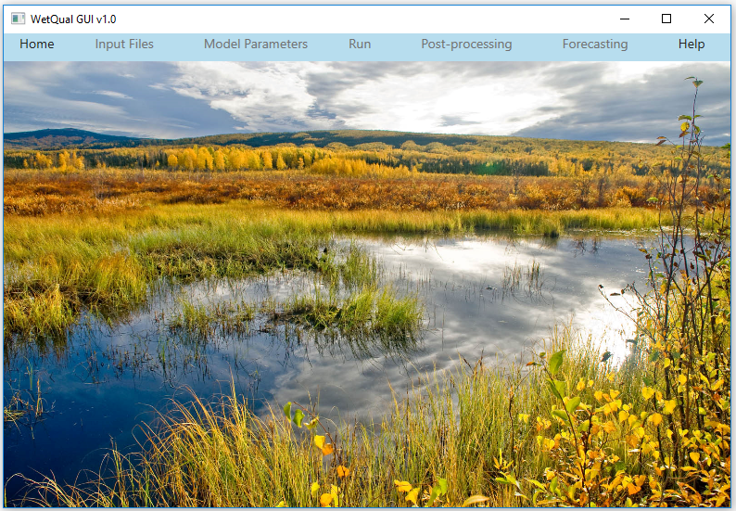

Figure 3.1

## Home

The Home menu contains items that control the setup and management of projects. This menu includes Open Project, New Project, Save As and Exit sub-menus (Figure 3.2).

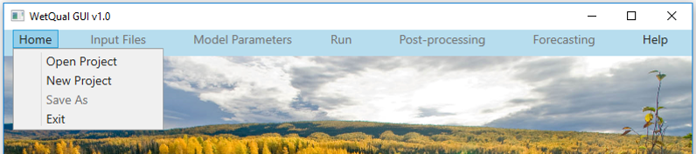

Figure 3.2

### Open Project

The user can select Open Project under the Home menu to load a previously created project or one of the example projects provided with the GUI. Loading an existing project activates all the menus in the GUI, meaning that the user will have access to the Post-processing and Forecasting (only with the stochastic runs) menus.

On the navigation bar, clicking the **Home>Open Project** will pop up the window shown in Figure 3.3. After selecting the folder where the project resides, press “OK”to open the selected project.

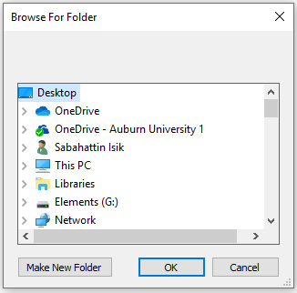

Figure 3.3

Note that when a wrong folder is opened through Open Project tab, the user will get the error message shown in Figure 3.4. The user needs to select a folder that contains at least the “InputOutput” and “Observations” folders with the required input files inside them.

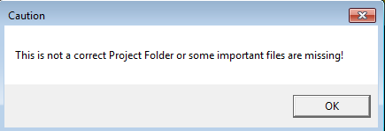

Figure 3.4

### New Project

This option is for creating a new project. When a project is created, the Input Files menu will be activated. The user needs to provide a starting date of simulation, hydro-climate data, basic parameters, initial concentration, and input concentrations for the project.

On the navigation bar, click on Home>New Project and it will pop up the “Browse For Folder” dialog box as shown in Figure 3.3. The user needs to navigate to the folder where the new project will be stored. After creating (by using “Make New Folder”, Figure 3.3) or selecting an available folder (not necessarily an empty folder), click “OK”. User needs to make sure that he/she has the administrative rights to access and create new files inside the folder. The GUI copies sample input/output files/folders under the selected or newly created folder. The GUI guides the user to update these files step by step.

### Copying a Project

The Save As option copies the project user is currently working on to a new folder. Since running a button saves or shows the requested process in each step, the GUI does not have a separate “Save” option in order to save processes before exiting.

## Input Files

The Input Files menu contains Select Start Date, Hydro-Climate Parameters, Basic Parameters, and Water Quality sub-menus which are needed to set up a new project. Figure 3.5 displays these sub-menus.

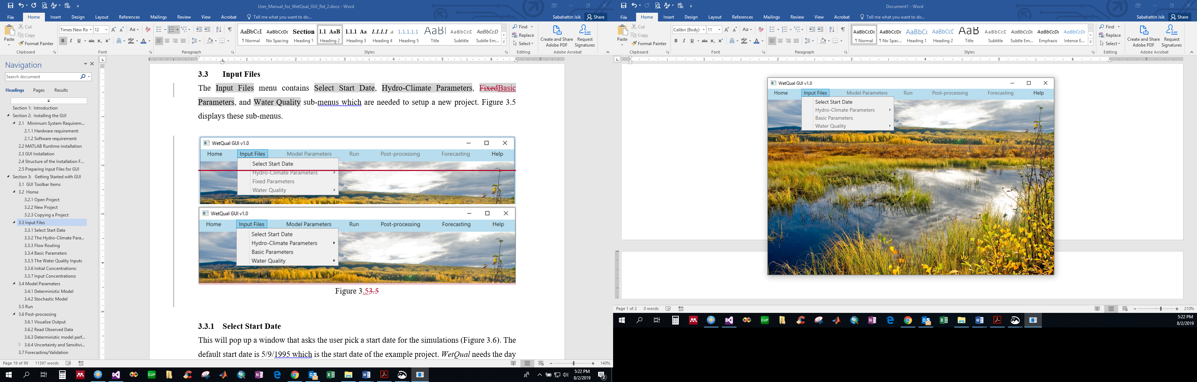

Figure 3.5

### Select Start Date

This will pop up a window that asks the user to pick a start date for the simulations (Figure 3.6). The default start date is 5/9/1995 which is the start date of the example project. If the date format on the user’s computer is not month/day/year format, date format should be changed in region settings of the computer. *WetQual* needs the day number within a year (Julian days) for the equations governing the rooted/benthic plant growth/death. Hence, having a starting day of simulation helps keep track of the Julian days for related calculations in the model. After choosing the date, the user needs to “Confirm” it.

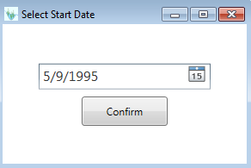

Figure 3.6

### The Hydro-Climate Parameters

The Hydro-Climate Parameters menu can be used to upload pre-existing hydro-climatic data and/or to perform flow routing to calculate time series of wetland area, volume, and outflow (Figure 3.7). If time series of wetland area, volume and outflow values are available in advance, flow routing is not needed. If ET data is not available, the GUI can calculate ET as explained later (enter zero for all ET values initially). If *Twater, Qout, Area,* and *Vw* are also not available, they can be entered zero “0” or any numbers. In this case, they should be replaced in the following steps explained below. Selecting Pre-existing Data opens up the “Select a File for Hydro-Climate Data” window (Figure 3.8) for browsing and selecting the related file (here, hydro-climate input file). The name of the file does not necessarily have to be “*12_hydro_climate.txt*” as shown in Figure 3.8.

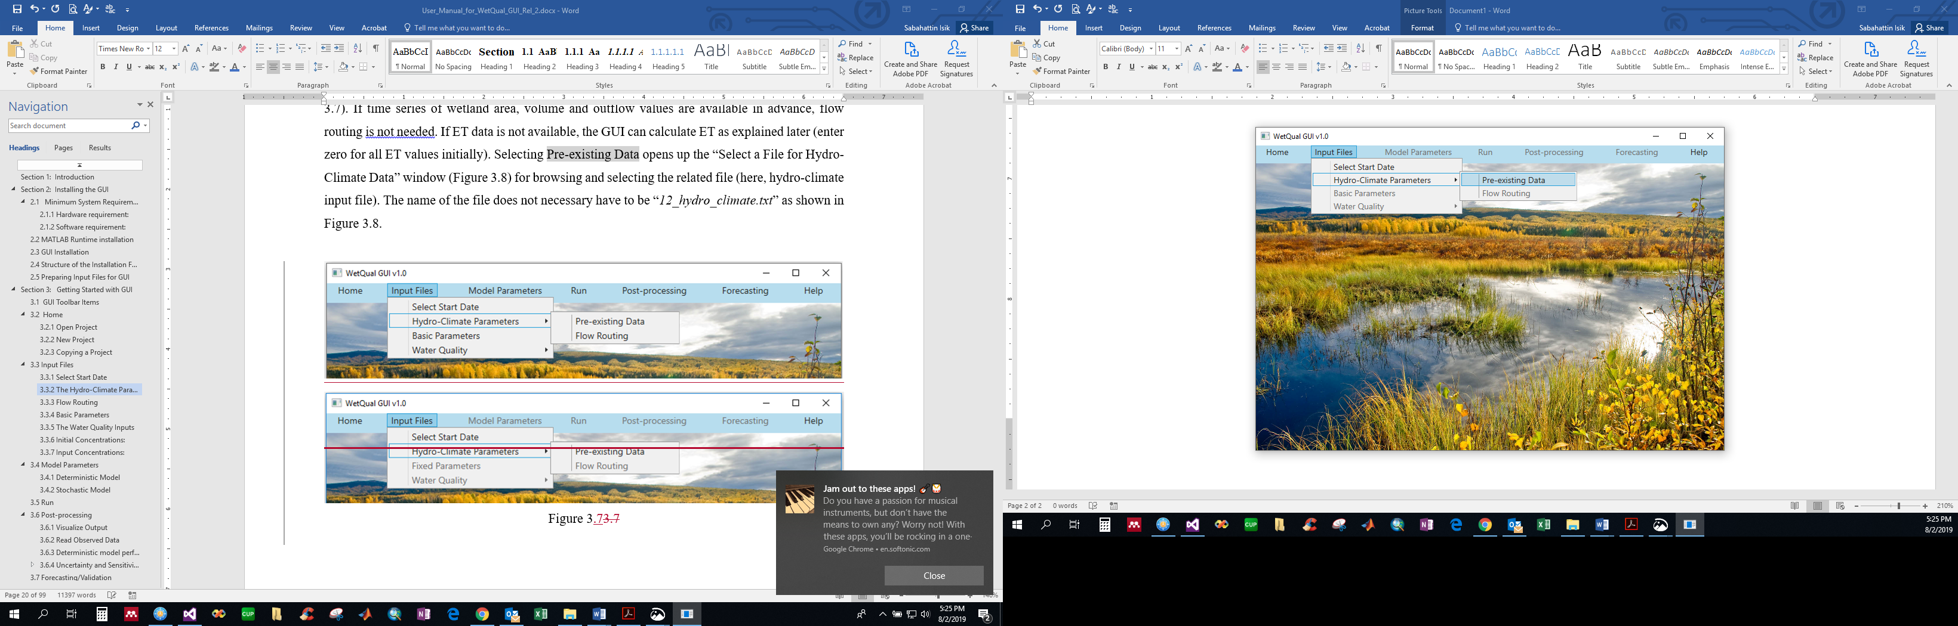

Figure 3.7

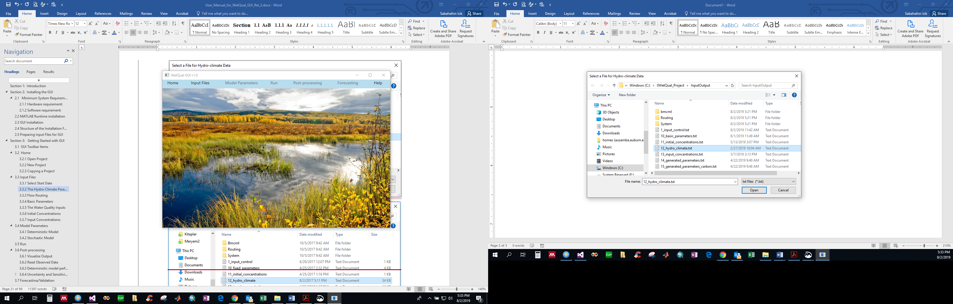

Figure 3.8

Figure 3.9 shows a sample hydro-climate data. Data in this file are space delimited. The first two rows are for parameter symbols and their units. User needs to follow the same format when they define a new project. Once the user selects this file, GUI reads, checks, and writes information of it with the name “*12_hydro_climate.txt*” and puts it under the “InputOutput” folder.

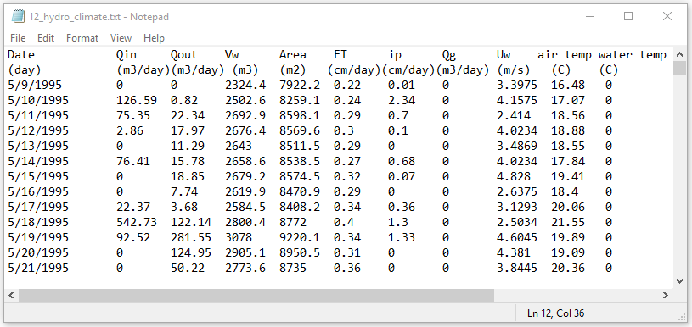

Figure 3.9

Once the hydro-climate file is selected, the “Hydro-Climate Data” window will pop up (Figure 3.10), which shows the same hydro-climate in table format. If data on selected file are not in the correct format or a wrong file selected, GUI will give an error as shown in Figure 3.11 or in Figure 3.12. In such a case, the GUI will not continue to the next step and will not allow further processing until valid data are provided. User needs to close windows and try again after correcting the format of data.

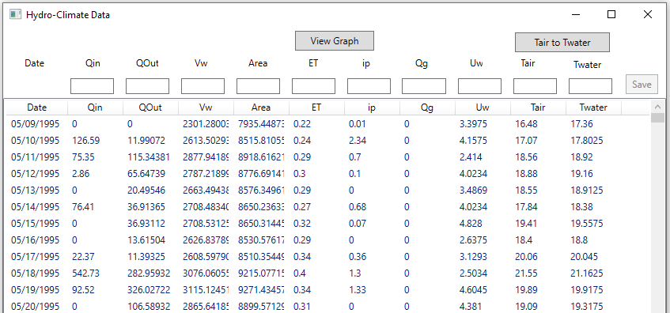

Figure 3.10

Hydro-climate data requires time series data for inflow rate (*Q*in, m3/day), outflow rate (*Q*out, m3/day), volume of wetland (*V*w, m3), wetland surface area (*A,* m2), Evapotranspiration rate (*ET,* cm/day), precipitation rate (*ip,* cm/day), groundwater discharge (*Q*g, m3/day; negative for infiltration/recharge), wind speed (*U*w, m/s), daily average air temperature (*T*air, °C), and daily water temperature (*T*water, °C), respectively. More details about the definitions, symbols, and units are given in Appendix. Users must follow this order when preparing Hydro-Climate data for their projects. If the user does not have *T*water data, daily average air temperature (*T*air) can be provided and daily water temperature (*T*water) data can be entered as zeros. *WetQual* GUI can use *T*air to estimate *T*water using the equation developed by Stefan and Preud’homme (1993) for a well-mixed stream:

$$T_{water}= 5.0+0.75{ T}_{air}$$

By clicking on the Tair to Twater button on the Hydro-Climate Data window, the $T_{water}$ values will be computed in both “Hydro-Climate Data” window and hydro-climate input file (Figure 3.13). User does not need to perform this step if they have *T*water data in the hydro-climate input file.

**Note: Do not add any blank row at the end of input files.**

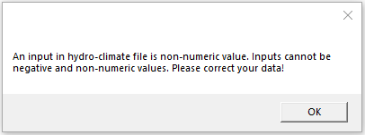

Figure 3.11

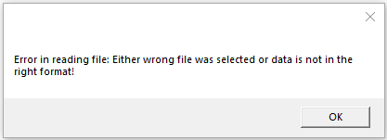

Figure 3.12

Users can edit any value by choosing the row in which the data are located. In Figure 3.13, the third row is selected as an example. GUI shows the selected row at the top, which is editable. After editing the value(s), the user needs to select the Save button to save the changes. If the window is closed without saving, any changes made will be lost. Also, the parameters come with a tooltip meaning that the definition and the unit (if applicable) of a parameter is shown when the cursor is held over the symbol of the parameter. Clicking the View Graph button pops up a new window and the user can select a parameter to see its time-series graph. On the graphical report page (

Figure 3.14), the user can pick other parameters from the pull-down menu and the graph will be automatically updated. The graphs are dynamic and the user can zoom in or out any part of the graph.

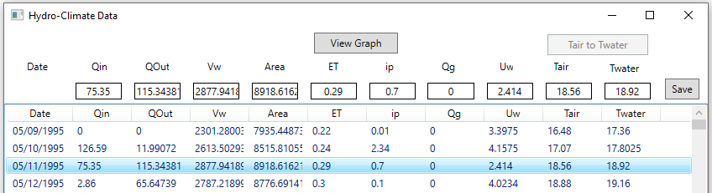

Figure 3.13

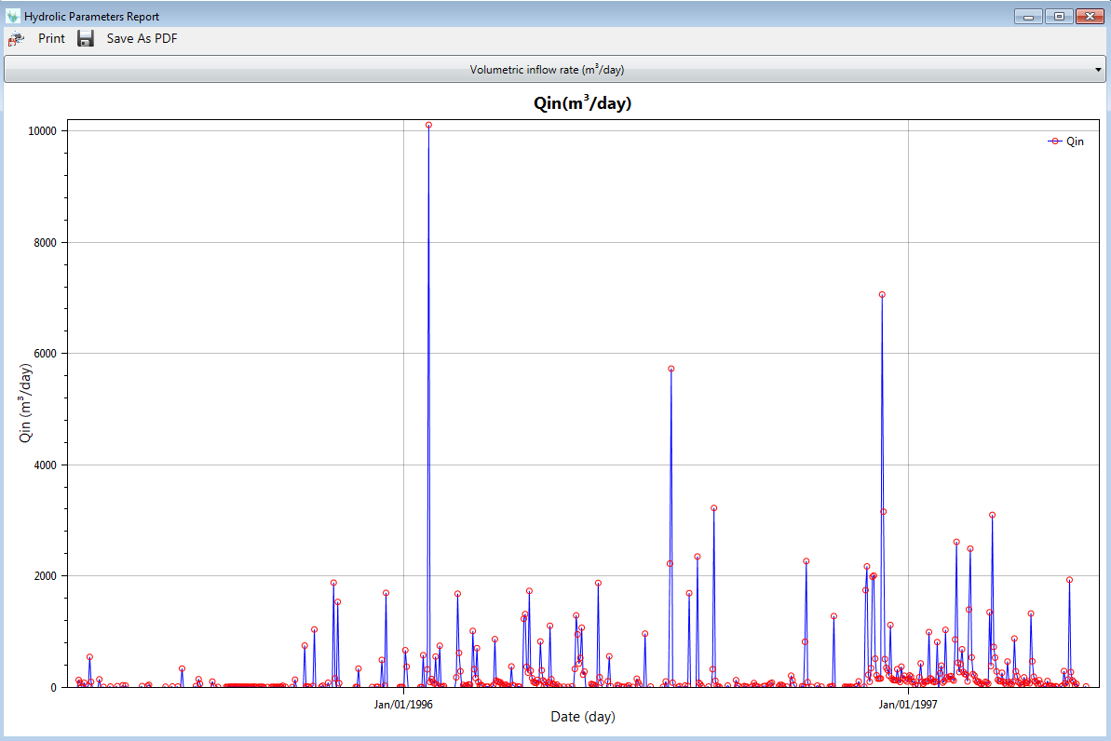

Figure 3.14

### Flow Routing

If time series of wetland area, volume and outflow are unavailable, the user needs to perform flow routing using the Flow Routing menu (Figure 3.15) to generate the necessary hydrologic data. Flow routing in the WetQual GUI is based on the solution of the continuity equation using third-order Runge-Kutta method. User can navigate to Flow Routing section by following: **Input Files>** **Hydro-Climate Parameters>** **Flow Routing** (Figure 3.15). The user still needs to follow the Pre-existing data importing procedure described above before performing flow routing. The user needs to enter zero for Qout, Vw and Area in the hydro-climate data file. Those values will be updated once flow routing is completed.

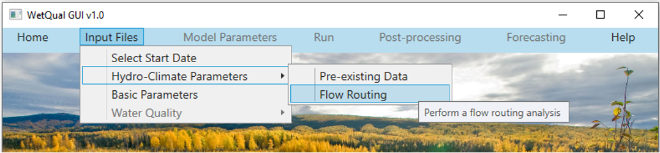

Figure 3.15

Clicking the Flow Routing menu opens up the “Flow Routing” window as shown in Figure 3.16. As can be seen, there are four tabs, which are explained below.

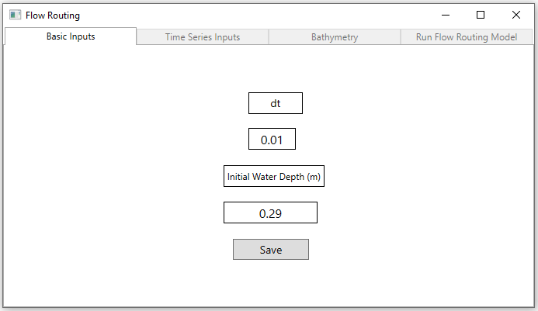

Figure 3.16

#### Basic Inputs

On this window (Figure 3.16) user needs to provide the time step (*dt*) of flow routing simulations and the antecedent water level in the wetland (*Hinitial*). Once *Hinitial* and *dt* are provided and the Save button is clicked, the GUI will create control file “*1_basic_inputs.txt*” that is needed for the flow routing module (Figure 3.17) and display the message in Figure 3.18.

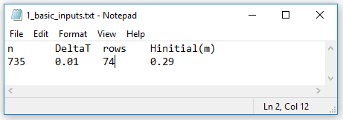

Figure 3.17

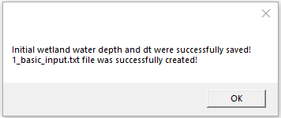

Figure 3.18

#### Time Series Inputs

After clicking the Save button in the Basic Inputs tab, Time Series Inputs header will be activated. As can be seen in Figure 3.19, after clicking the Time Series Inputs header, the user will see “*2_time_series_inputs.txt* file was successfully created!” message. This file is automatically created by the GUI under the “InputOutput\Routing” folder using the hydro-climate data described earlier. If the user gets an error message, the data format should be corrected. This file consists of the data shown in Figure 3.20: inflow to the wetland, *Q*in (m3/day), evapotranspiration rate, *ET* (cm/day), precipitation rate, *ip* (cm/day) and groundwater discharge into the wetland, *Q*g (m3/day).

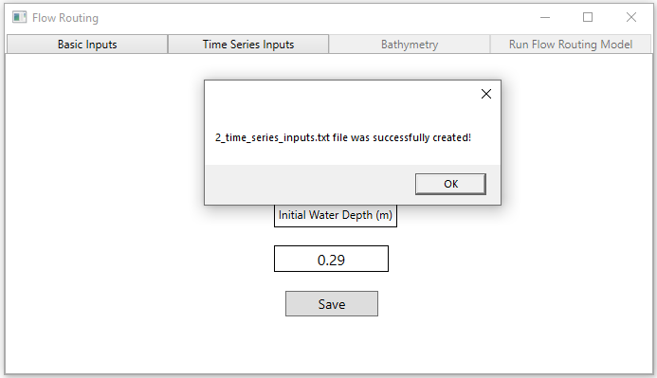

Figure 3.19

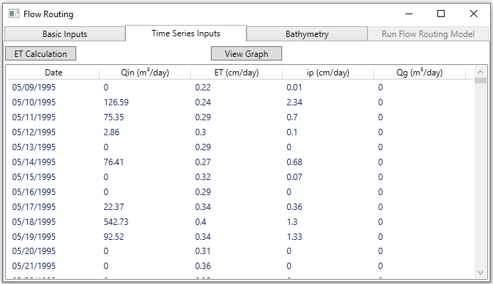

Figure 3.20

If the user does not have ETdata, ET part of the Time Series Input file should have all zero values as mentioned earlier. In this case user needs to calculate ET with the GUI using the Hamon method (Hamon, 1961). Clicking the ET Calculation button will prompt the GUI ask the user latitude of the wetland (Figure 3.21). When user clicks the Save button, the “*1_ETinputs.txt”* file was successfully created!” message will appear. This text file contains the data required for ET calculation. The GUI prepares this file using the data provided in the hydro-climate data and creates a copy of it under the name “*1_ETinputs.txt*” under the “InputOutput\Routing\ET Module” folder. Note that “*ET.txt*” file seen in this folder is the output of the ET calculation.

As can be seen from Figure 3.22, the input file required for ET calculation requires number of simulation days (*n*) (, latitude (decimal degree) of the study wetland, and the time series of Julian days and daily average air temperature (°C).

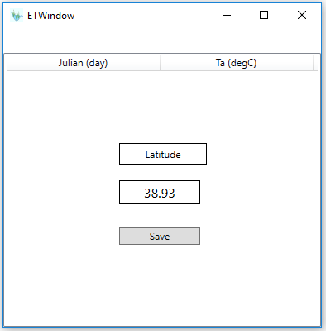

Figure 3.21

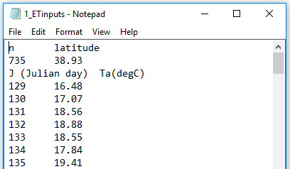

Figure 3.22

After the required data are provided, clicking the Calculate ET button will perform the calculations and the user will get a confirmation message once it is complete (Figure 3.23 and Figure 3.24). The ET column of the Input Time Series file, which was initially assigned zero values, will then be updated.

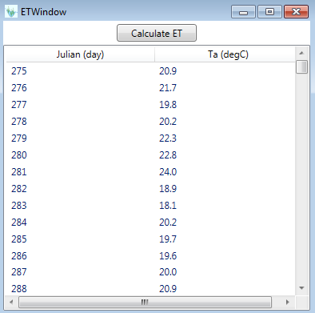

Figure 3.23

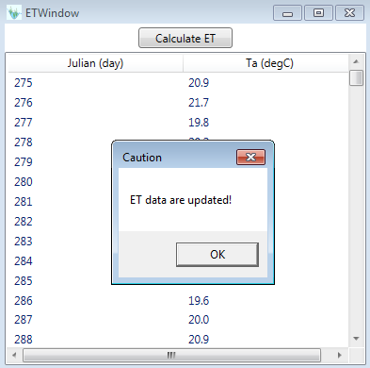

Figure 3.24

#### Bathymetry

By selecting the Bathymetry header, the user needs to browse to the relevant folder and select the file that contains wetland bathymetry data. The GUI reads, checks and creates a copy of the input file provided by the user with the name “*3_bathymetry_inputs.txt*” under the “InputOutput\Routing” folder (Figure 3.25). The “*3_bathymetry_inputs.txt*” file should contain reference depth of water in the wetland, *H* (m), wetland surface area, *Area* (m2), water volume of wetland surface water, *Volume* (m3) and outflow rate (m3/day) (Figure 3.26). Figure 3.27 shows the bathymetry data in the table after the file is selected. This is essentially a depth-area-volume-outflow relationship table.

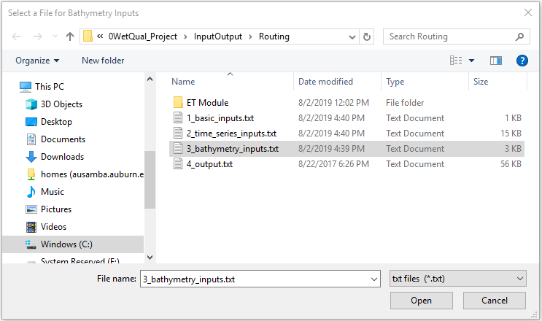

Figure 3.25

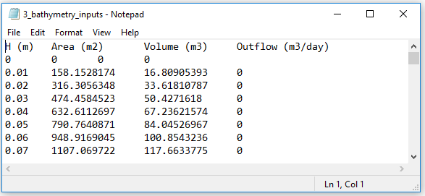

Figure 3.26

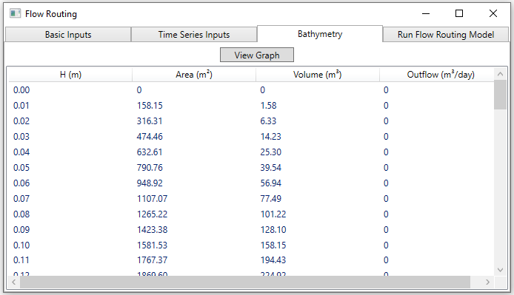

Figure 3.27

Clicking “View Graph” button plots Depth-Area, Depth-Volume, and Depth-Outflow relationships of the wetland. Figure 3.28 shows the plot of Volume vs Depth r for the data shown in Figure 3.26.

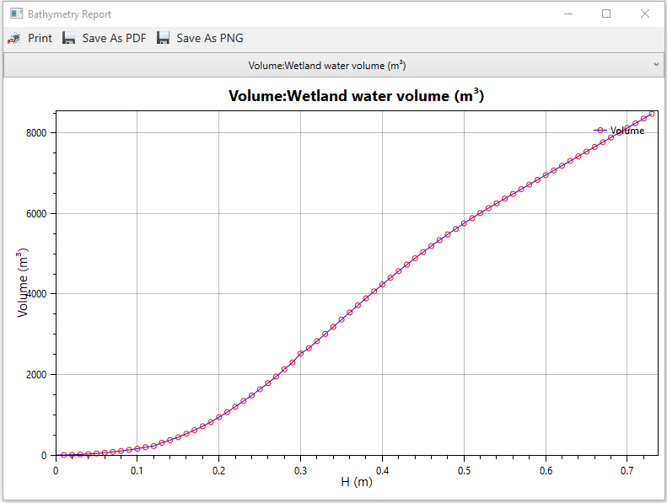

Figure 3.28

#### Output

After assigning the aforementioned input files, the user clicks the Output tab to run the flow routing and also see the results, which are time series of wetland water depth, outflow, area, and volume (Figure 3.29). Transfer Output button transfers the calculated values to the pre-defined hydro-climate data for *WetQual* run.

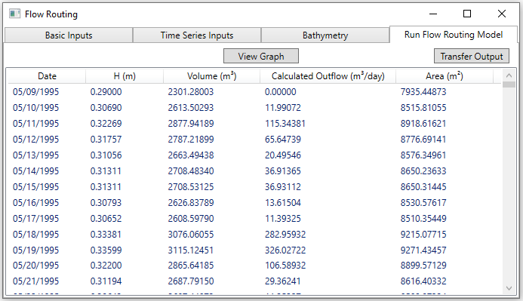

Figure 3.29

By clicking the View Graph button, the user can choose among the outputs to see the graph of the variable of interest. As an example, calculated *H* and *Q*out are shown in Figure 3.30 and Figure 3.31.

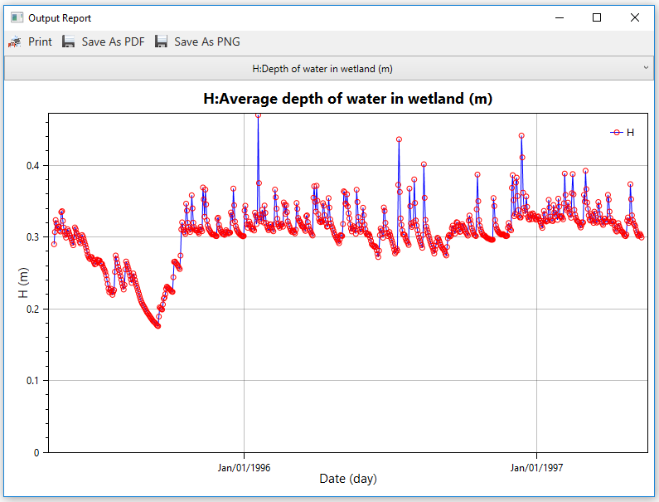

Figure 3.30

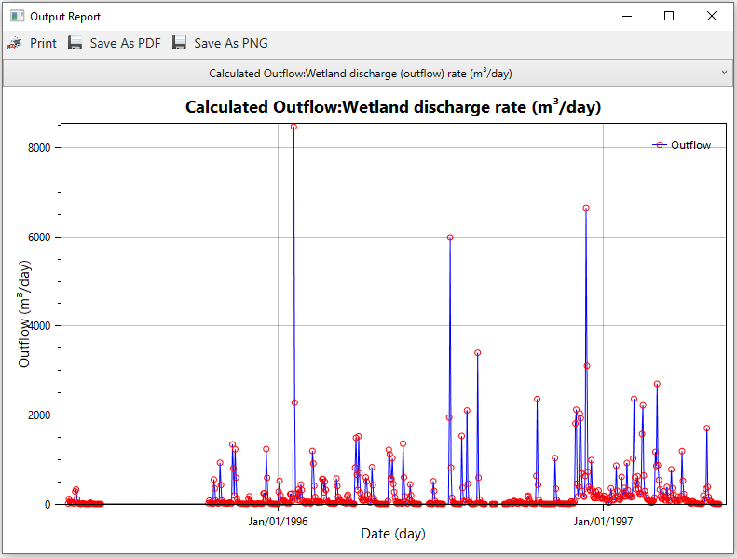

Figure 3.31

### Basic Parameters

The Basic Parameters menu under the Input Files (Figure 3.32) is used to assign the time-independent model parameters. Selecting Basic Parameters opens the window shown in Figure 3.33 which asks the user to select the related input file. Basic parameters input file should include parameters shown in Figure 3.34 (formatting should follow the exact same order; it is a space-delimited file). The list of parameters in this menu are summarized in Table A. 2 in the Appendix. Selecting the basic parameters file opens the dialog window shown in Figure 3.35.

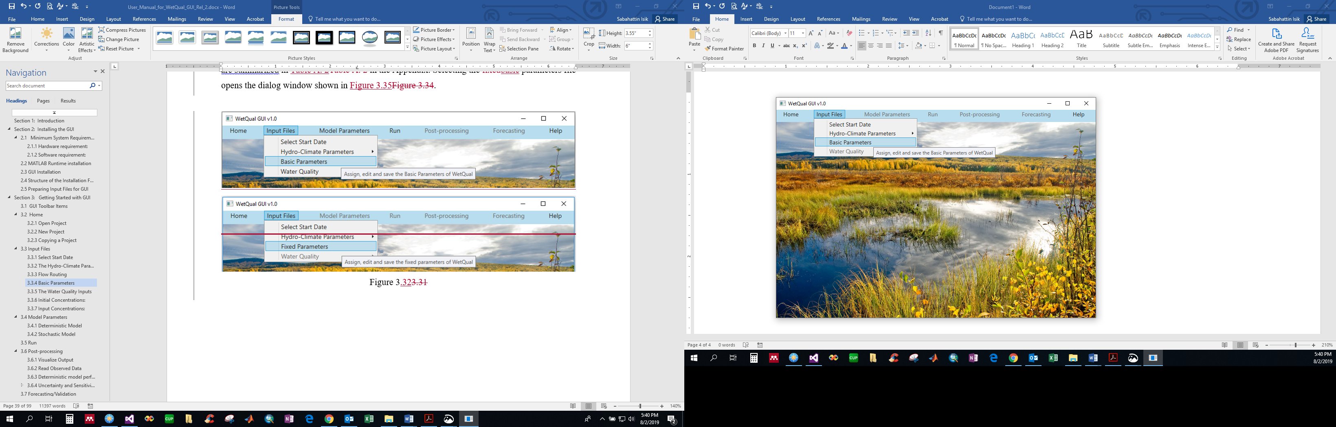

Figure 3.32

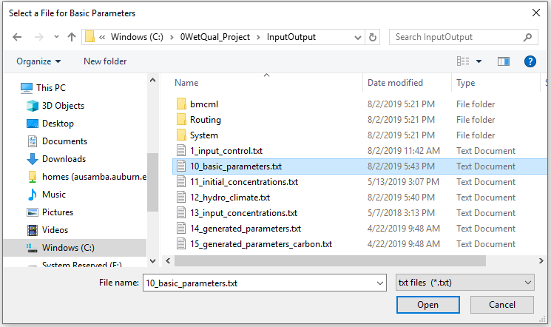

Figure 3.33

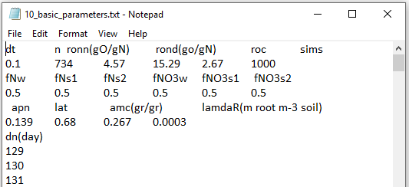

Figure 3.34

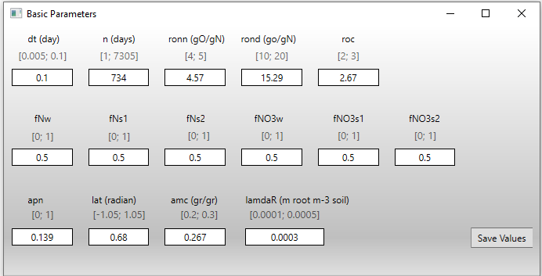

Figure 3.35

The recommended minimum and maximum values of all basic parameters are provided within brackets [ ] under each parameter. The parameter values are editable and Save Values button allows the user to save the changes. There is a validation procedure that is carried out after clicking the Save Values button. The validation is to check if the value of a parameter is within its defined range. Otherwise, the user will see an error message like the one seen at the bottom of Figure 3.36, “The value of the parameter is outside the range.” The box containing the relevant parameter will be highlighted in red. The recommended minimum and maximum values of basic parameters are provided in a text file named “MinMaxBasicParameters.txt” under the <InputOutput> folder (Figure 3.37). Users can edit this file if they want to make changes in values of minimum/maximum values.

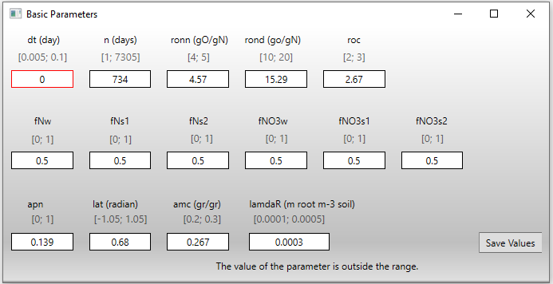

Figure 3.36

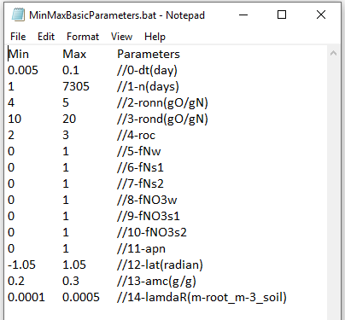

Figure 3.37

The user will see the message “Data saved successfully!” once the validation is successful. Figure 3.38 shows the respective message which is being displayed when the values are saved successfully. Also, the parameters come with a tooltip meaning that the definition and the unit (if any) of a parameter is shown when the mouse cursor is held over the symbol of the parameter.

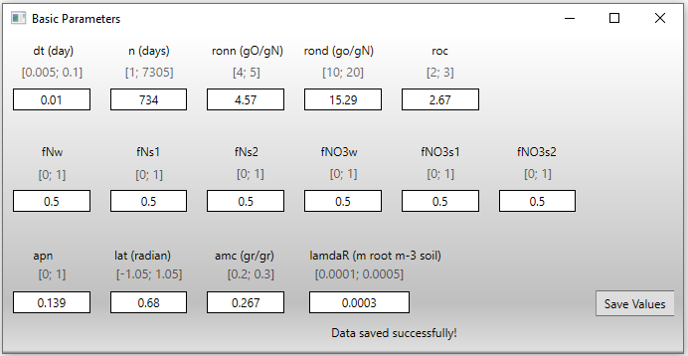

Figure 3.38

### The Water Quality Inputs

The Water Quality menu (Figure 3.39) is used to import “Initial Concentrations” and “Input Concentrations” of nitrogen (N), phosphorus (P), total suspended sediment (TSS) and carbon (C) and to view Input Concentrations. The related input files for these two menus are “*11_initial_concentration.txt*” and “*13_input_concentrations.txt*” files, respectively, located in “InputOutput” folder of the project.

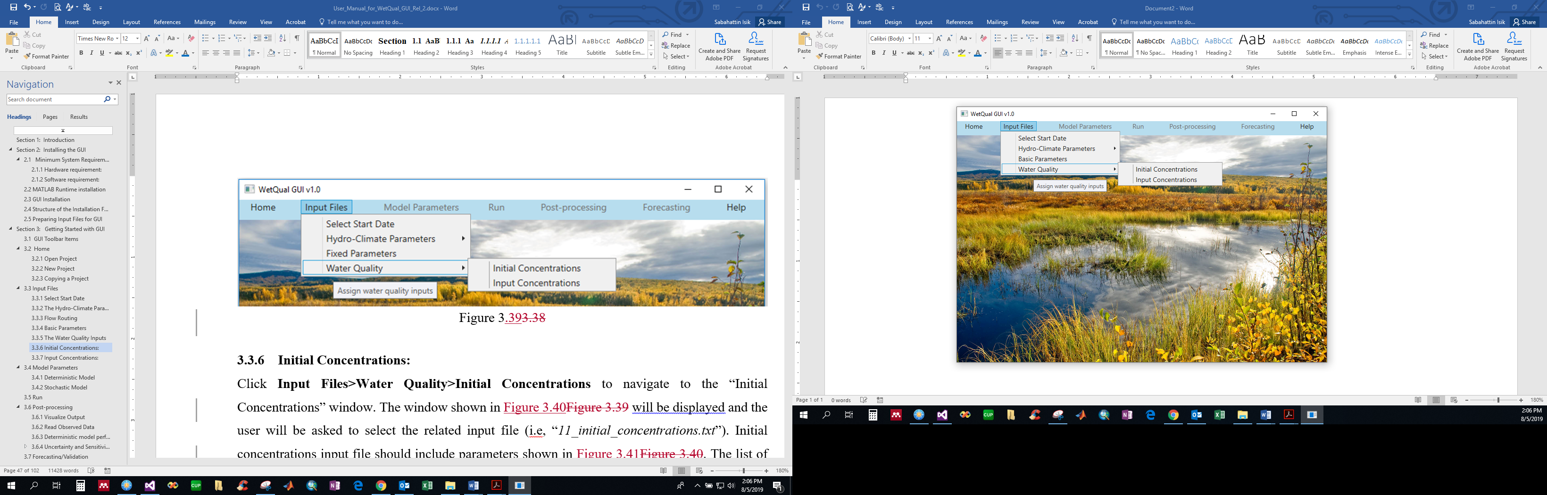

Figure 3.39

### Initial Concentrations:

Click **Input Files>Water Quality>Initial Concentrations** to navigate to the “Initial Concentrations” window. The window shown in Figure 3.40 will be displayed and the user will be asked to select the related input file (i.e, “*11_initial_concentrations.txt*”). Initial concentrations input file should include parameters shown in Figure 3.41. The list of parameters in this file are summarized in Table A. 4 in the Appendix. After selecting the file, the “Initial Concentrations” window shown in Figure 3.42 pops up. The values are editable and Save Values button allows user to save the changes. The parameters come with a tooltip meaning that the definition and the unit (if applicable) of a parameter is shown when the mouse cursor is held over the symbol of the parameter.

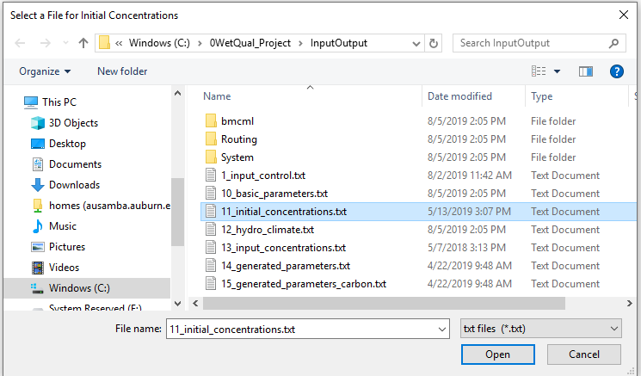

Figure 3.40

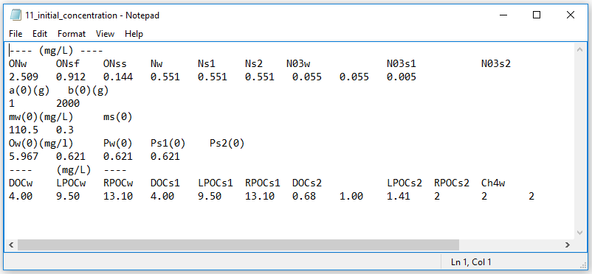

Figure 3.41

As mentioned before, there is a validation procedure that is carried out after clicking the Save Values button. The validation is done to check if there is any “Empty Field” or “Negative Value”. The user receives the same error or success message (Figure 3.43 and Figure 3.44).

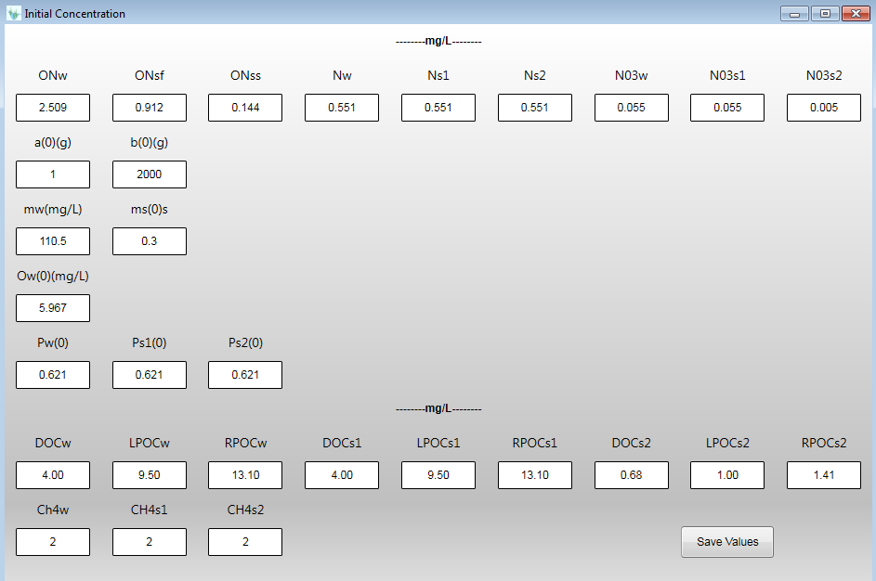

Figure 3.42

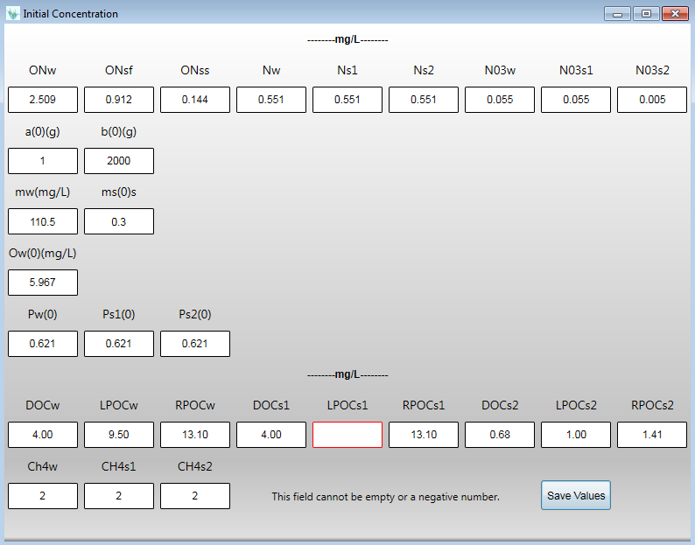

Figure 3.43

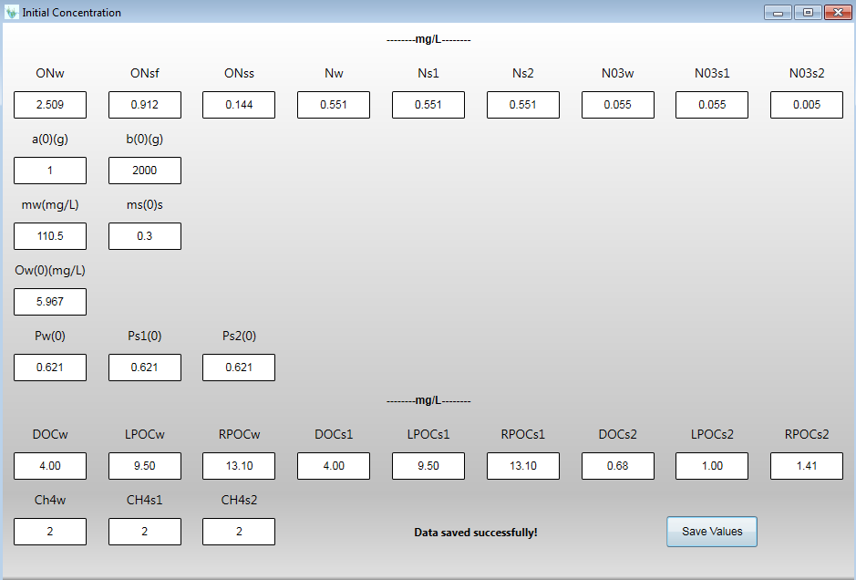

Figure 3.44

### Input Concentrations:

On the navigation bar, click **Files>Water Quality>Input Concentrations**, to open the “Input Concentrations” window. The user is asked to provide the related input file (i.e., “*13_input_concentrations.txt*”) (Figure 3.45). The user can see the time series of the wetland water quality constituents in the example input concentration file in Figure 3.46. The list and definitions of water quality constituents in this file are given in Table A. 5 in the Appendix. GUI will read and check data on the selected file and name it as “*13_input_concentrations.txt*” under the “InputOutput” folder after writing data on the file. If the GUI does not find data in the required format, it will give an error message. In this step, the user needs to update the file with the correct format. After selecting the file, the “Input Concentration” window shown in Figure 3.47 pops up. User can view the time series of the data in tables and graphs where they can edit and save the Input Concentrations, if necessary. By choosing a row, the related data can be edited and the user needs to save the changes by clicking the Save button on the upper right side of the window (Figure 3.47).

Same as previous windows, a validation procedure is also carried out after clicking the “Save” button for any “Empty Field” or “Negative Value”.

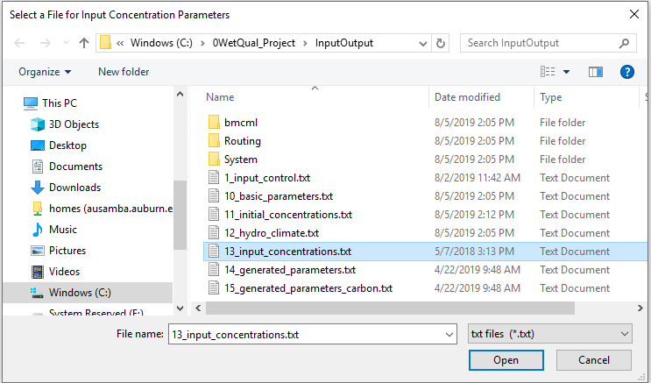

Figure 3.45

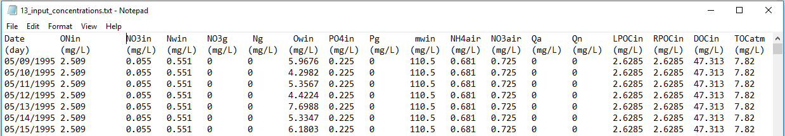

Figure 3.46

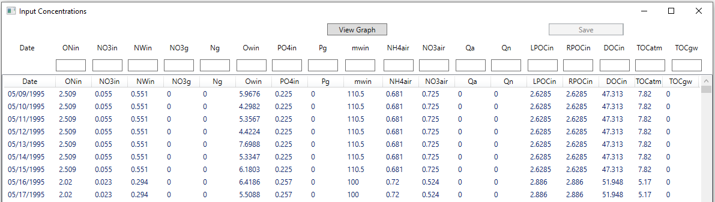

Figure 3.47

## Model Parameters

In this step, some of the *WetQual* parameters which are considered to be random in the stochastic model (some biogeochemical parameters and reaction rates) are introduced. As can be seen from Figure 3.48, the GUI allows *WetQual* to be run in either deterministic or stochastic mode. To that end, after selecting the Deterministic Model or Stochastic Model option, the user will have the opportunity to define the values of the model parameters or their statistical distributions. For stochastic model parameters, suggested ranges (Min, Max) and distributions for the listed parameters/coefficients were extracted from literature and expert knowledge (e.g. Schnoor, 1996; Chapra, 1997; Di Toro, 2001; Reddy and Delaune, 2008; Cerco and Cole, 1995, and Ji, 2008). See Hantush et al. (2013), Kalin et al. (2013) and Sharifi et al. (2013) to find details about *WetQual* parameters.

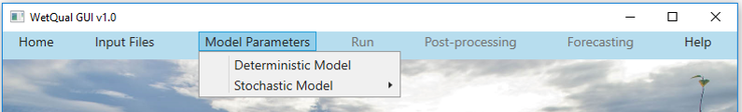

Figure 3.48

### Deterministic Model

On the navigation bar, clicking **Model Parameters>Deterministic Model** will navigate the user to “Default values for model parameters” window. For Deterministic model, the median of the selected range for each model parameter was chosen to serve as the default value. In the related window (Figure 3.49), user can see the default values. Users can edit, save and restore the values back to their defaults by using Save Values and Default Values buttons. A list of all parameters in this window is presented in the Appendix. Clicking on Save Values button activates the Run Simulations option, if there is no error. The parameters come with a tooltip meaning that the definition and the unit (if any) of a parameter is shown when the mouse cursor is held over the symbol of the parameter. Same as previous windows, a validation procedure is also carried out after clicking the Save Value button for any “Empty Field” or “Negative Value”.

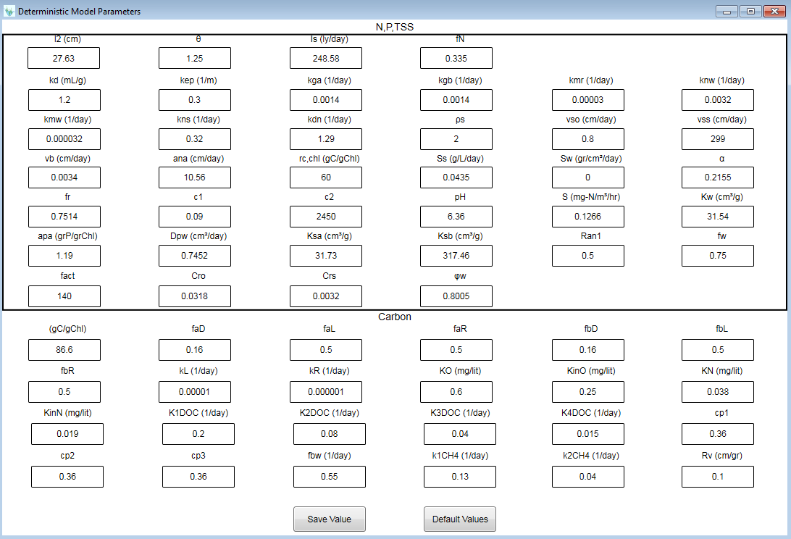

Figure 3.49

### Stochastic Model

On the navigation bar, clicking the **Model Parameters>Stochastic Model** (Figure 3.50) will activate the stochastic mode of the *WetQual* GUI and open the “N, P, TSS” (Figure 3.52) and “Carbon” windows (Figure 3.53). In these two windows, the user needs to select the distribution type and relevant statistics. Users are given the option to choose from four probability distributions: uniform, normal, log-normal or triangular (Figure 3.51).

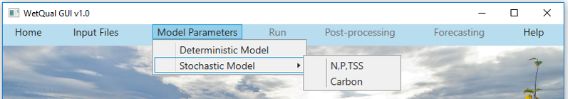

Figure 3.50

Minimum and maximum values are required for uniform and normal distributions. For log-normal distribution, the user needs to provide either minimum and maximum values or mean (*μ*) and standard deviation (**). Note if Min and Max values are provided, they are assumed to correspond to probabilities of 0.1% and 99.9%. The GUI internally calculates *μ* and ** from those. For triangular distribution, the peak location (*c*) is required in addition to min and max values. Users can change both distribution types and parameter values and they can save their changes for a specific project by clicking on the Save Values button.

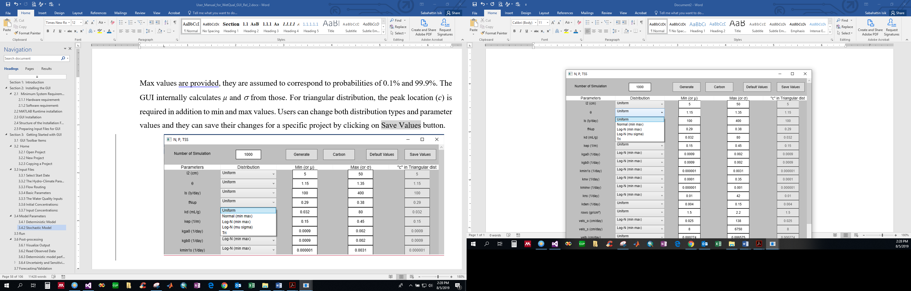

Figure 3.51

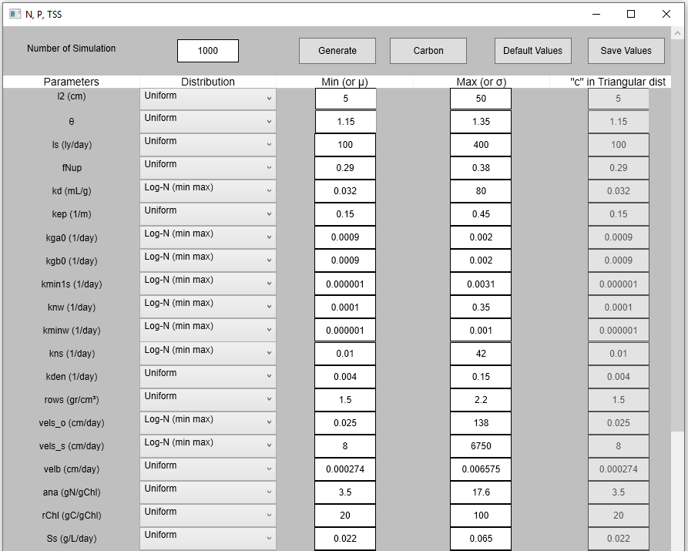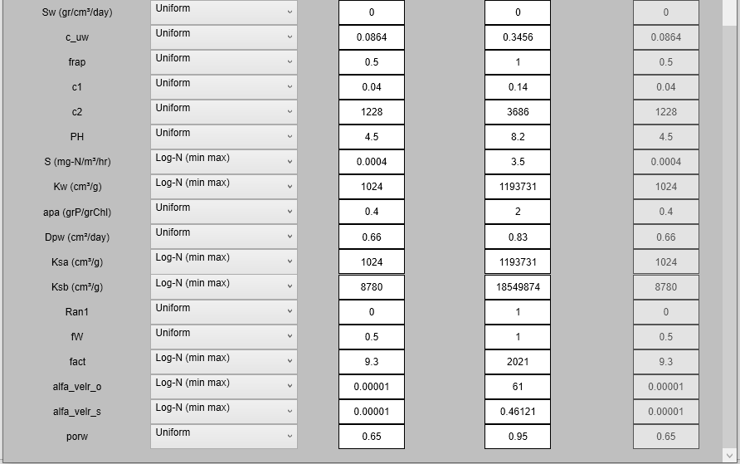

Figure 3.52

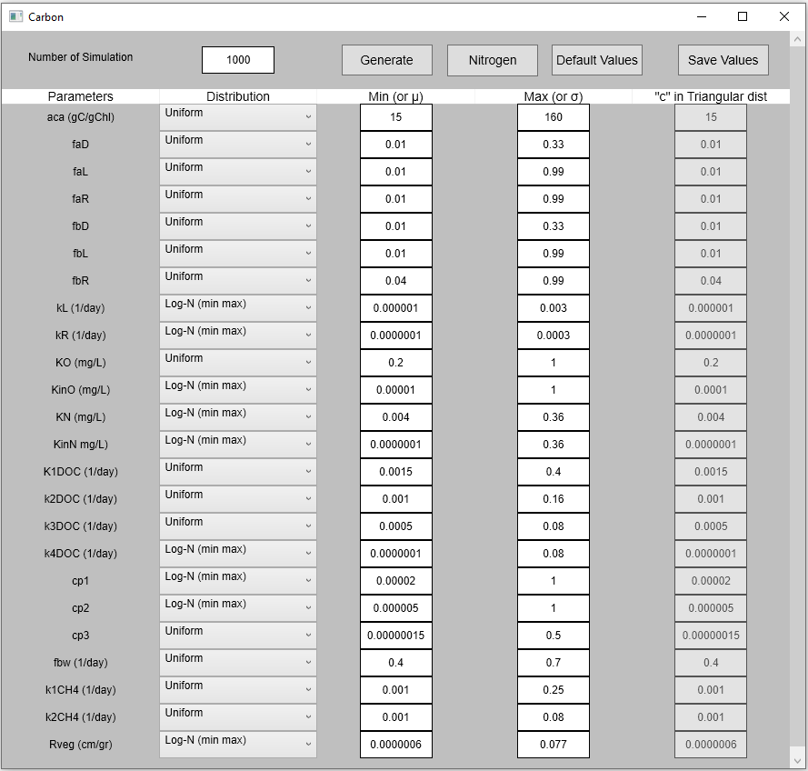

Figure 3.53

As it is shown in Figure 3.51 and Figure 3.53, the user must choose the number of simulations for generation of parameter sets based on the assigned distribution types and the parameter ranges. Clicking the Generate button (Figure 3.51 and Figure 3.53), GUI randomly generates parameter values and updates the files “*14_generated_parameters.txt*” and “*15_generated_parameters_carbon.txt*”. User can select Carbon button to move to that window. Moving the mouse cursor on the symbols of parameters in both “N, P, TSS” and Carbon windows will show the definitions of parameters.

## Run

After all parameters have been assigned (for deterministic model) or randomly generated (for stochastic model), click Run. Under that menu, the user will see the Run WetQual button (Figure 3.54). If the user assigns deterministic model parameters or generated stochastic model parameters in the last step, the GUI runs the deterministic model or the stochastic model, respectively. Note that the models run are actually the same. The stochastic model performs Monte Carlos simulations with the same model. After executing “Run WetQual”, one of the following pop-up messages will display depending on the selection: “Deterministic model was successfully executed” or “Stochastic model was successfully executed” (Figure 3.55). By clicking the Run WetQual button, the relevant model (deterministic or stochastic) will be executed. Since the deterministic model will perform only one simulation, it may take a couple of seconds to finish. But, depending on the number of the simulations and the processor, it may take from a couple of minutes to couple hours to complete a run under the stochastic scenario. Once the deterministic mode run is finished, Post-Processing menu will be activated (see Figure 3.56). Running the *WetQual* GUI in stochastic mode will additionally activate the GLUE and BMCML sub-menus under the Post-Processing menu and the Forecasting menu.

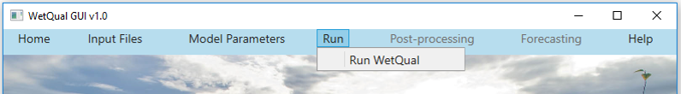Figure 3.54

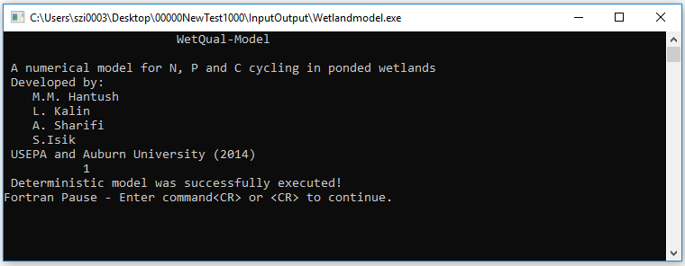

Figure 3.55

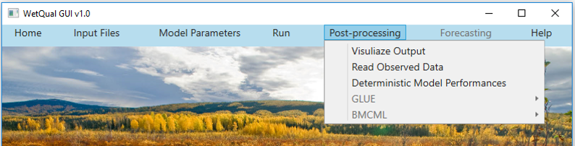

Figure 3.56

## Post-processing

### Visualize Output

***Deterministic Model***

Visualize Output provides an opportunity to visualize both deterministic and stochastic model outputs through a series of graphs. Figure 3.57 displays the window that pops up after clicking Visualize Output for the deterministic model. Users can select the output of interest (out of 29 *WetQual* outputs for N, P, TSS and C, see Table A. 6 in Appendix) to see the time-series graph of an output. As an example, the time-series graph for particulate organic nitrogen concentration in free water (*Now*) is shown in Figure 3.58. In addition to the time-series graph, by selecting the Time Series Table in this window, one can see the actual simulated values in time series (see Figure 3.59). Furthermore, the user can print the graphs or save them in pdf format. For the sake of simplicity and GUI performance efficiency, the *WetQual* output (text files) are saved under the “InputOutput” folder.

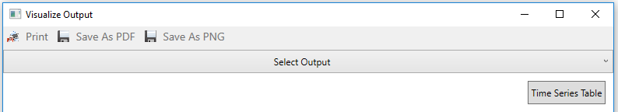

Figure 3.57

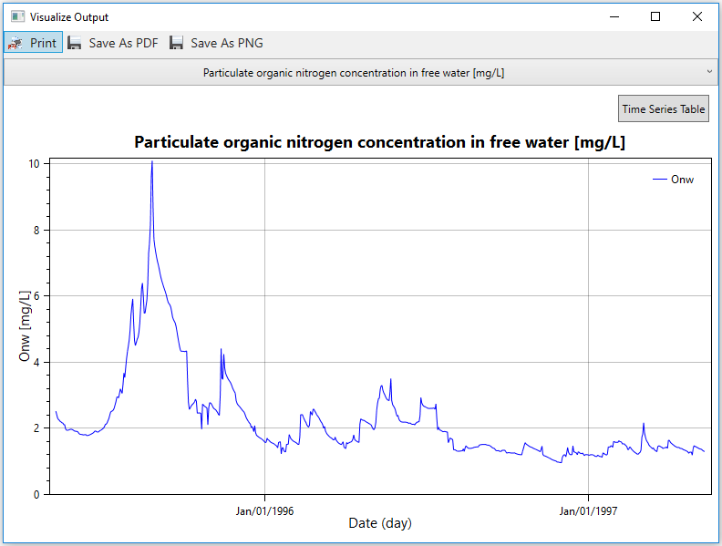

Figure 3.58

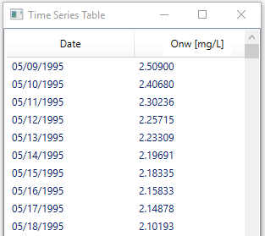

Figure 3.59

***Stochastic Model***

Since the stochastic model results in an ensemble of outputs, an option was added to allow the user to choose among the number of simulations in Analyze Output Files. Users can pick any simulation number and visualize its outputs. Figure 3.60 displays the Analyze Output Files window before a parameter of interest is selected.

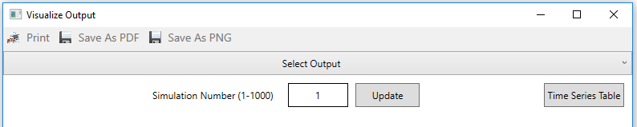

Figure 3.60

As an example, we run WetQual with 1000 simulations and the simulation number 380 was selected to visualize the results (Figure 3.61). If the user picks a simulation # outside the range, an error appears similar to Figure 3.62. The user has also an option to visualize the results of previous or next simulations by simply clicking “Previous” and “Next” buttons.

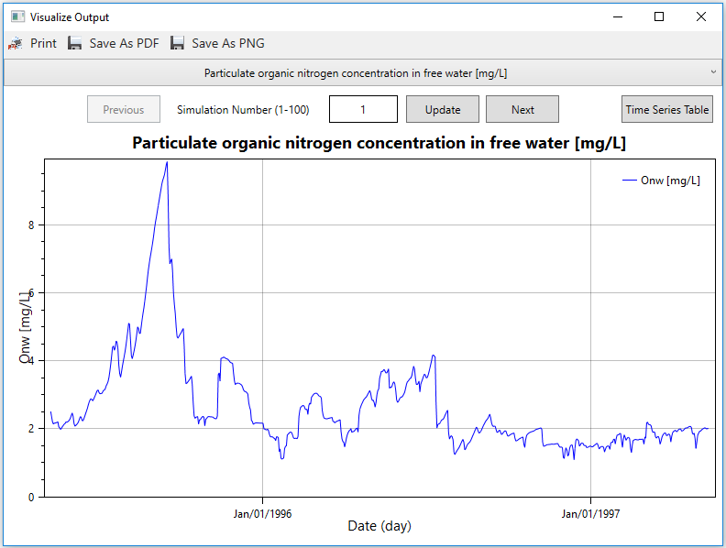

Figure 3.61

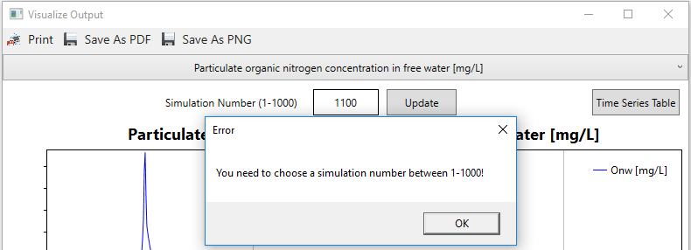

Figure 3.62

### Read Observed Data

Observed values of model outputs are needed to assess model performances and perform uncertainty/sensitivity analysis. When the user clicks Read Observed Data under the Post-processing menu (Figure 3.63), the window in Figure 3.64 is displayed, and the user is asked to select the observed data file. The observation data file format is shown on the top in Figure 3.63. Available constituent numbers, which are available in lines 3-6, should be given in the first line in the observation file. SD at the eighth line refers to the duration of the data collection period. If there is no data, SD should be “-999”. The user needs to provide data on the available dates.

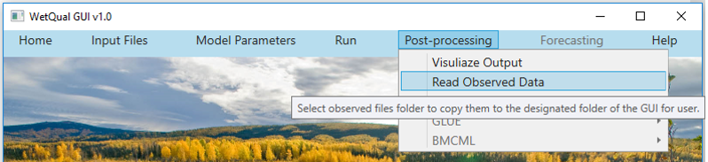

Figure 3.63

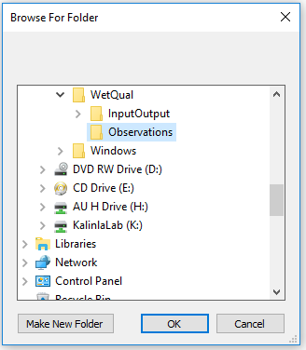

Figure 3.64

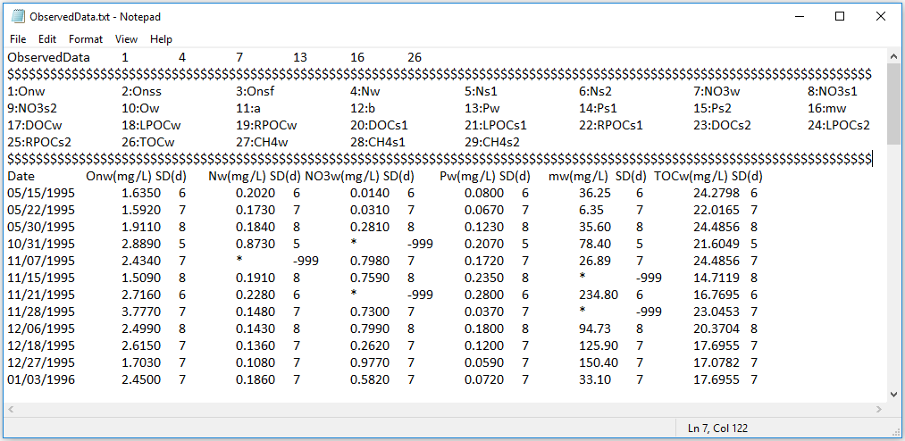

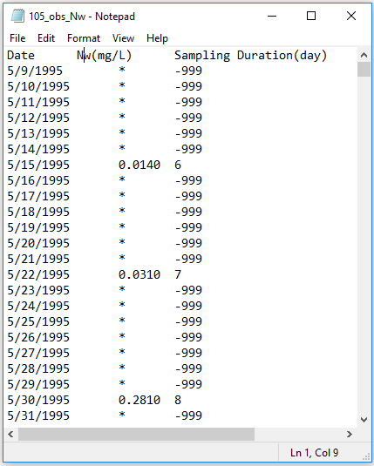

Figure 3.65

The GUI will convert the observation data file to separate files for each constituent in the required daily format. On the bottom in Figure 3.63, the format and schematic of a typical observation file is shown. The first column is for date and the second column is for the observations. The last column shows the duration of the data collection period for that entry in days (if data is flow-weighted average of certain number of days). If data are daily or instantaneous, “1” should be entered next to the observation in the last column. If data are flow-weighted average, say of the previous 6 days, then “6” should be entered next to the observation value as seen in Figure 3.65. Days with no data need to have “*” in the second column and “-999” in the last column. Note that the format is “space delimited”. Users need to prepare their observation files in a folder and pick that folder from Read Observed Data menu during Post-processing. Note that users don’t need to follow this procedure (of picking “Observation” folder by using Read Observed Data menu) if they have already put their observed files under the “Observations” folder under the project folder.

### Deterministic model performances

If a deterministic model run was performed, then under the Post-processing menu only Deterministic Model Performances sub-menu will be activated as seen Figure 3.66. When the user clicks the Deterministic Model Performances sub-menu, a new window will open as illustrated in Figure 3.67. In this window, the user can select the model outputs for which observations are available. GUI provides time-series graphs of observed data versus model outputs (Figure 3.68). On the upper right side of the window, the performance metrics Nash-Sutcliffe efficiency (*E*NS), Mass Balance Error(*MBE*) and Normalized Root Mean Square Error (NRMSE which is RMSE divided by the average of observed values) are presented for the selected output variable. Performance metrics are calculated by

$$E_{NS}=1-\left[\frac{\sum_{i=1}^{m}{{{(y}_{obs,i}-y_{sim,i})}^{2}}}{\sum_{i=1}^{m}{{{(y}_{obs,i}-{\overline{y}}_{obs})}^{2}}}\right]$$

$$MBE \left(\%\right)=\left[\frac{\sum_{i=1}^{m}{{(y}_{obs,i}-y_{sim,i})}}{\sum_{i=1}^{m}{{(y}_{obs,i})}}\right]*100$$

$$NRMSE=\frac{\sqrt{\frac{1}{m}\sum_{i=1}^{m}{{{(y}_{obs,i}-y_{sim,i})}^{2}}}}{{\overline{y}}_{obs}}$$

where, *y*obs,i, *y*sim,i denote observed and simulated values at the *i*th observation, respectively, ${\overline{y}}_{obs}$ refers to the average observed value and *m* represents the number of observations.

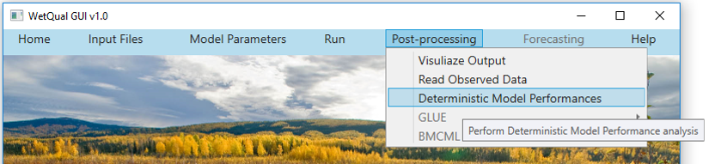

Figure 3.66

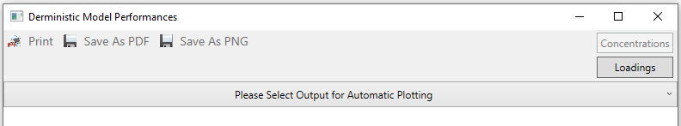

Figure 3.67

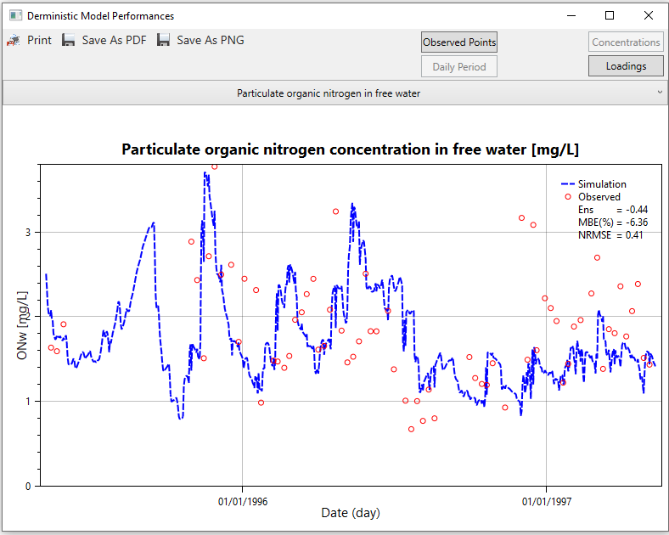

Figure 3.68

The GUI can plot the results only for the times where observed data is available or for the daily period. The Observed Points and Daily Period button can be used to switch between the two options. If observed data are flow-weighted average of a certain number of days, the GUI will plot the results only for those periods with no time association as seen in Figure 3.69. The performance values are also calculated using the weighted values. The GUI can plot both concentration and loading results. The Concentrations and Loadings buttons can be used to select the desired option. More detail information can be found for these buttons under Section 3.6.4.

If observed data for a selected constituent is not available or not provided under “Observations” folder, the GUI will plot only model output as can be seen in Figure 3.70, and it will not calculate and thus show any performance metrics.

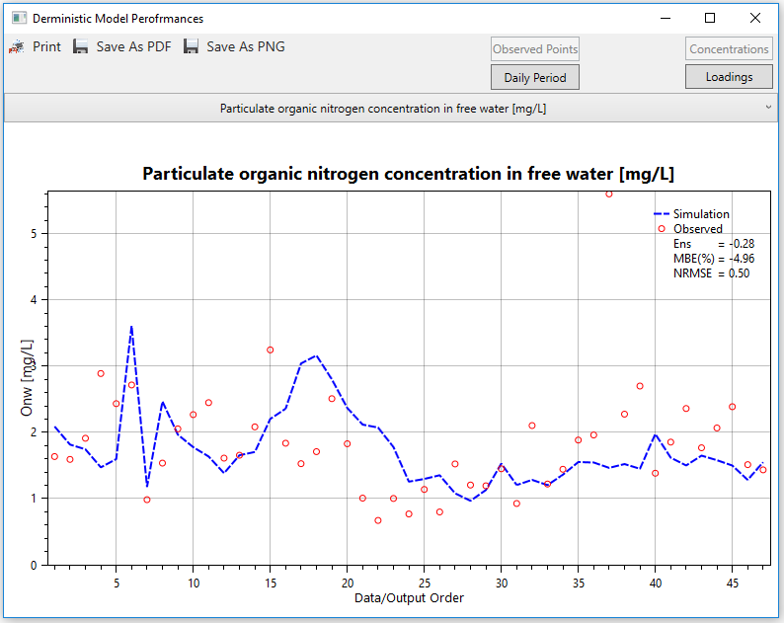

Figure 3.69

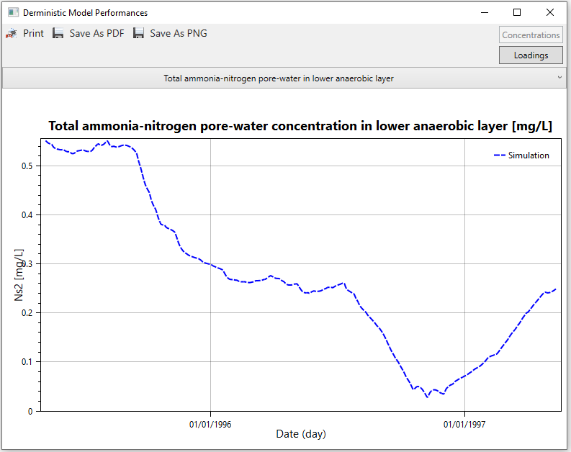

Figure 3.70

### Uncertainty and Sensitivity Analysis

Figure 3.71 displays the Post-Processing menu for the stochastic model, which includes Read Observed Data, Generalized Likelihood Uncertainty Estimation (GLUE) and Bayesian Monte Carlo simulation and maximum likelihood estimation (BMCML) analyses. Deterministic Model Performances sub-menu is deactivated during the stochastic model process.

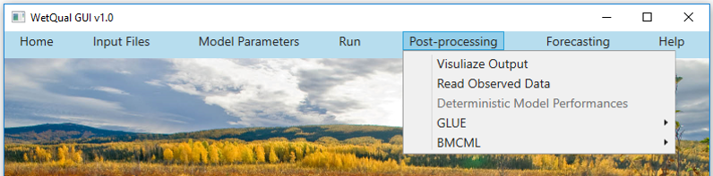

Figure 3.71

#### Uncertainty Analysis with GLUE:

The user will see the Uncertainty Analysis and Sensitivity Analysis sub-menus under the GLUE menu (Figure 3.72). Selecting the the “Uncertainty Analysis” command under the Post-processing>GLUE menu displays

*Figure* 3.73 before a model output of interest is selected. Here, the user can select either *Likelihood-1* or *Likelihood-2* (explained in the following paragraph) as the likelihood measure, which are used to separate the simulations and the related parameter sets into behavioral and non-behavioral sets. The default is “*Likelihood-1*”; the user has an option to continue with the default or change it to *Likelihood-2* at the beginning. After prediction bands of selected parameters are displayed, the user can change the calculation method again if he/she wishes to, by clicking the Likelihood-1 or Likelihood-2buttons, in which case the graph will be updated according to the selected method. The user can choose a *WetQual* output under the “Select Output” list for GLUE analysis (Figure 3.74). These likelihoods can be calculated by using either concentrations or loadings. The user can select “Concentrations” or “Loadings” by clicking the Concentrations and Loadings buttons (Figure 3.74).

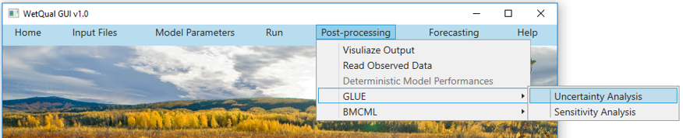

Figure 3.72

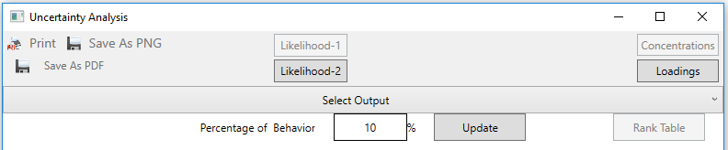

Figure 3.73

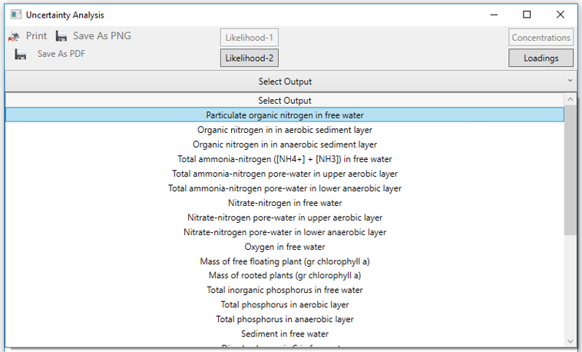

Figure 3.74

The *Likelihood-1*function utilized with GLUE in this GUI is a combination of Mass Balance Error (*MBE*) and *E*NS such that

$$L_{k1}=exp(E_{NS}-\frac{\left|MBE\right|}{100}-1)$$

The *Likelihood-2* function utilizes the Nash-Sutcliffe efficiency (*E*NS) and transform it to a value is between 0 and 1.

$$L_{k2}=exp(E_{NS}-1)$$

The user can update the results of the likelihood calculations by changing the percentage of their behavioral simulations from 1 to 10. For instance, if user selects 5%, then the simulations that produced the highest 5% likelihoods are selected as behavioral (B), and rest become non-behavioral (B’). The user needs to select the desired threshold. In the next step, behavioral (B) and non-behavioral simulations (B′) are separated. Following this, a graph for each model output is depicted which includes observations, behavior set (B), 95% prediction interval (P.I.) of BUB′, and the Median of all the simulations. Figure 3.75 shows an example graph of the Uncertainty Analysis window. The graph in the Uncertainty Analysis window also shows the performance metrics *E*NS, *MBE* and *NRMSE* for the best simulation which is the simulation having the highest $L_{k}$ or *E*NS.

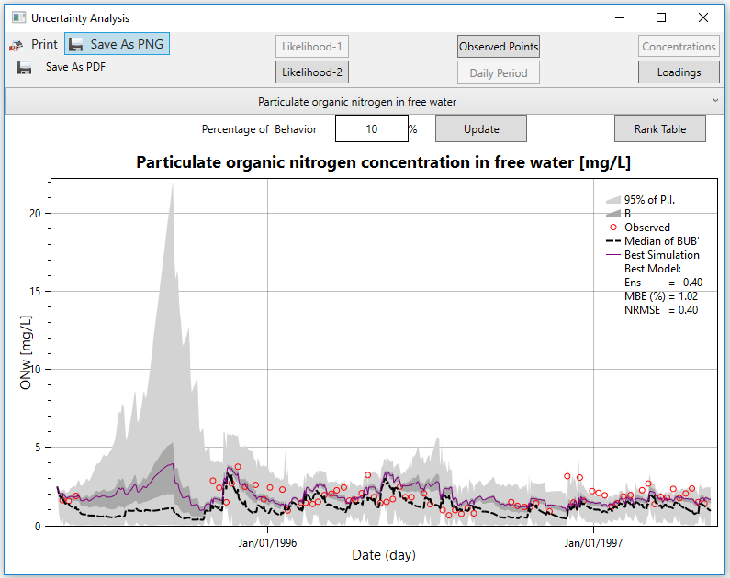

Figure 3.75

The GUI also writes these performance values to a text file and saves it under the name “*Performances_GLUE_102_Onw.txt*” (for Onw as selected model output) under the folder: “..ProjectName>InputOutput>glue”. When there is no observed data to calculate the likelihood values, 95% P.I for the whole simulations, as well as the median of the whole simulation are displayed. If there is no observed data for a constituent but its immediate parent constituents have data, their joint likelihood values are used to determine the behavioral set. In this case, the GUI also plots behavior set (B). Figure 3.76 displays an example of the situation where there is no measured data but parent constituents have observed data.

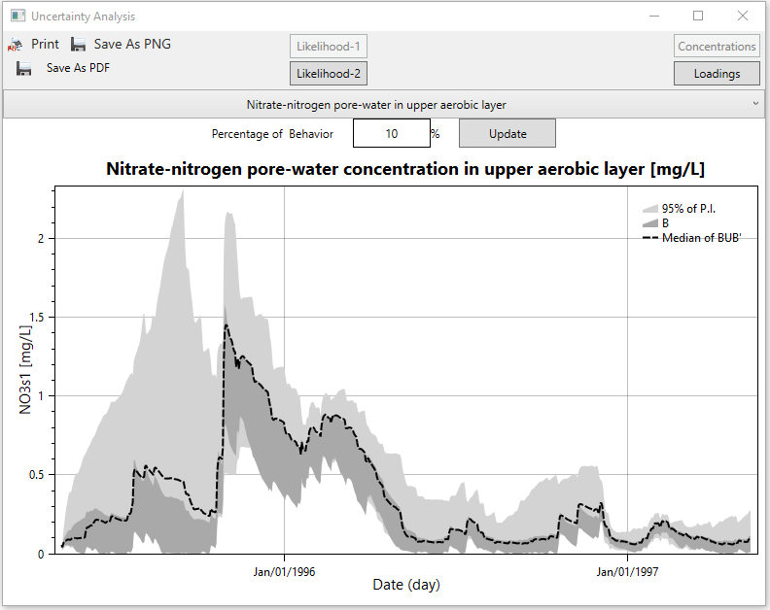

Figure 3.76

As can be seen in Figure 3.75, there is a button on the upper right side of the window named Rank Table. Clicking on that button generates a table similar to Figure 3.77, which provides the user with a table summarizing all the calculated likelihoods and *E*NS values in descending order. Whenever the user opens the Rank Table window, the GUI saves the table as a text file (e.g. “*RankTables_102_Onw.txt”*) under the >InputOutput>glue folder. The user has also an option to save the Rank Table under a different file name at any folder by clicking the Save button on the top right corner of the Rank Table window. As can be seen in Figure 3.76, the Rank Table button is invisible when there is no measured data.

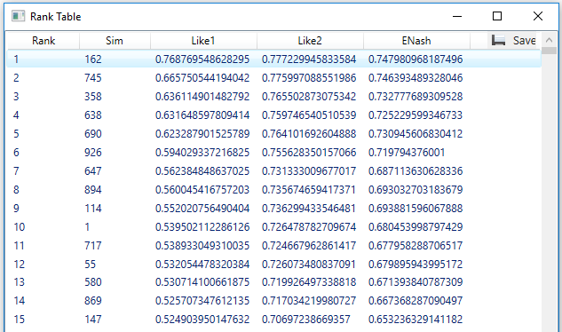

Figure 3.77

If observed data are daily or instantaneous values or not available, the GUI will plot GLUE results in a continuous time scale as shown in Figure 3.75 and Figure 3.76. If observed data are flow-weighted average of a certain number of days, the GUI will plot the results only for those periods with no time association (Figure 3.78-top). Users can also see the plot for the daily output by clicking the Daily Period (Figure 3.78-bottom). In this case, the observed data will be assigned to the last days of each sample collection on the graph. Clicking the Likelihood-1 or Likelihood-2 button reverts the plot to its previous state. The performance metrics will always be calculated using the flow-weighted values.

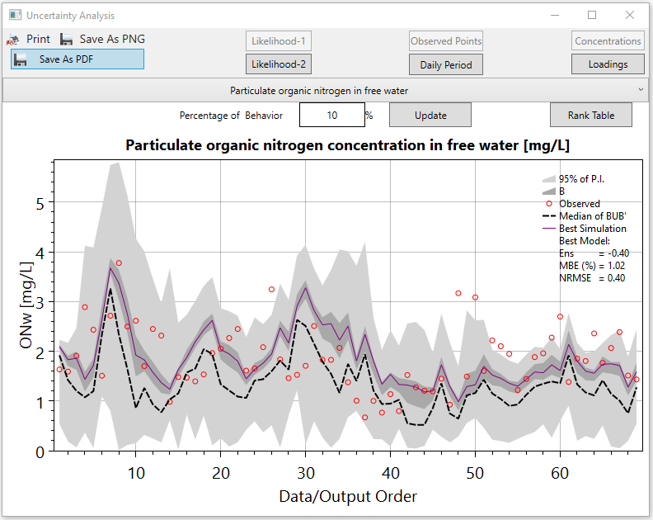

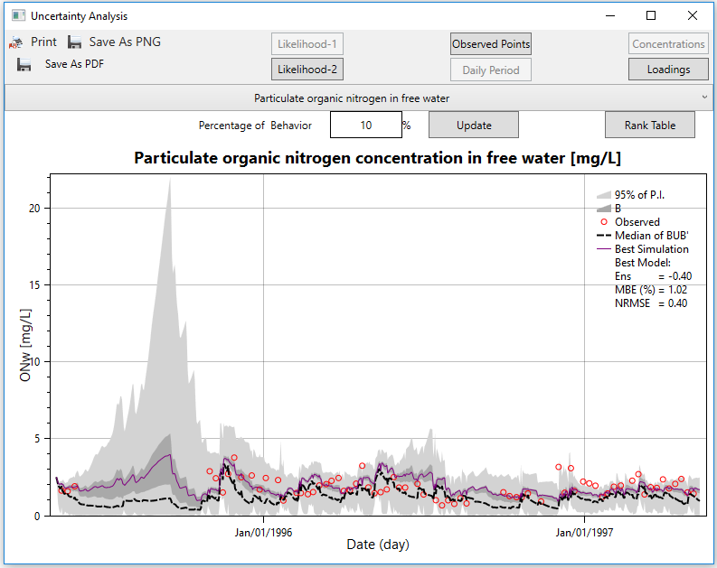

Figure 3.78

#### Sensitivity Analysis with GLUE

In the GLUE>Sensitivity Analysis menu of the *WetQual* GUI, global sensitivity analysis (GSA) and dotty plots are considered in order to evaluate the sensitivity of the *WetQual* outputs to various parameters. By using the *B* and *B*′ datasets, GUI performs Kolmogorov-Smirnov (K-S) test in the “Sensitivity Analysis” window. To that end, the cumulative distribution functions (CDFs) of the *B* and *B*′ are constructed for each parameter. Then, for each parameter, maximum deviation (*D*max) between the two CDFs are determined (Kalin et al. 2013):

$$D_{max}=max\left|{CDF}_{B}\left(x\right)-{CDF}_{B^{'}}\left(x\right)\right|$$

For a predetermined significance level of *α*, *p*-value< *α* indicates a sensitive parameters. For the sake of space, GUI displays the 20 most sensitive parameters by ranking the *D*max values from largest to smallest. In addition to the K-S test, dotty plots were added to the “Sensitivity Analysis” window. Dotty plots provide information about sensitive parameters and most importantly depict the range in which the model is most sensitive to a given parameter. They also reveal the optimal ranges of the values of each parameter where the model performs best (Kalin et al. 2013). Post-processing>GLUE>Sensitivity Analysis command opens the “Sensitivity Analysis” window (Figure 3.79). The user needs to select an output and then click “Start Calculation” button to see the Sensitivity Analysis results. Examples of the graphs in sensitivity analysis page (i.e., *D*max vs *p*-value) for Organic nitrogen concentration in free water (mg/L) for a test run with 10,000 simulations are displayed in Figure 3.80. W**e strongly suggest the users to have at least 1,000 simulations if they want to perform GLUE and/or BMCML analyses.**

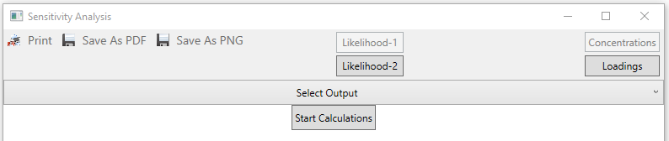

Figure 3.79

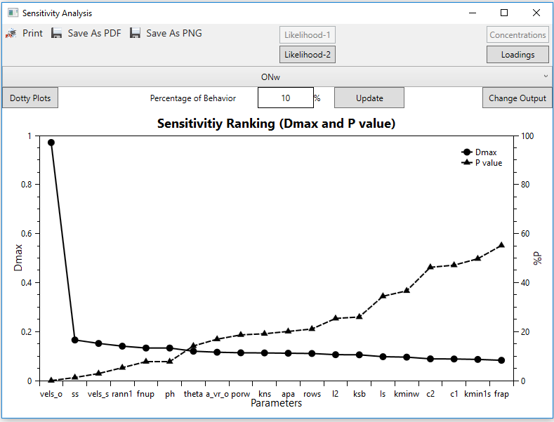

Figure 3.80

By clicking the “Change Output” button, the user can select the desired output. The Sensitivity Analysis window of the GUI will let the user visualize CDFs and dotty plots of the 20 most sensitive model parameters. By clicking CDF of a parameter of interest under the selected constituent bar (Figure 3.81),the GUI plots the CDFs of B and B’ of the selected parameter (Figure 3.82). The user can save the desired graph using “Save As PDF” or “Save As PNG” buttons in pdf or png format. The user can see the dotty plots of the 20 most sensitive parameters on the same window by clicking the “Dotty Plots” button on the upper left side of the Sensitivity Analysis window (Figure 3.83). The user can save dotty plots using the “Save As PDF” or “Save As PNG” buttons in pdf or png formats. The GUI saves each dotty plot in the figure in separate files.

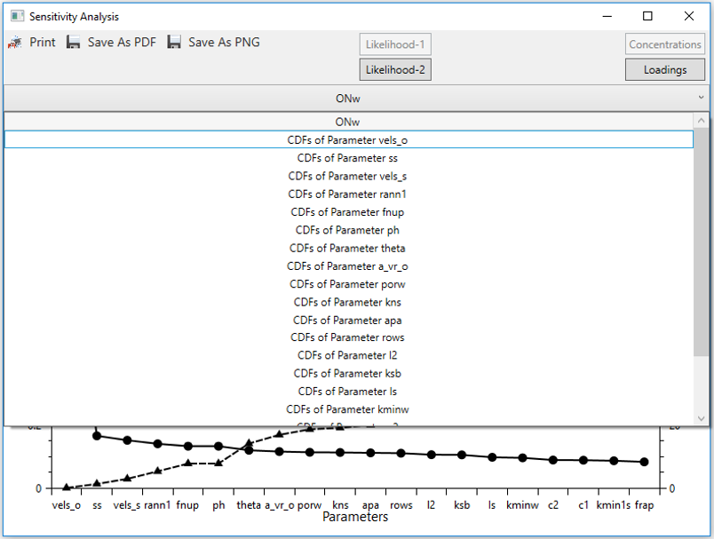

Figure 3.81

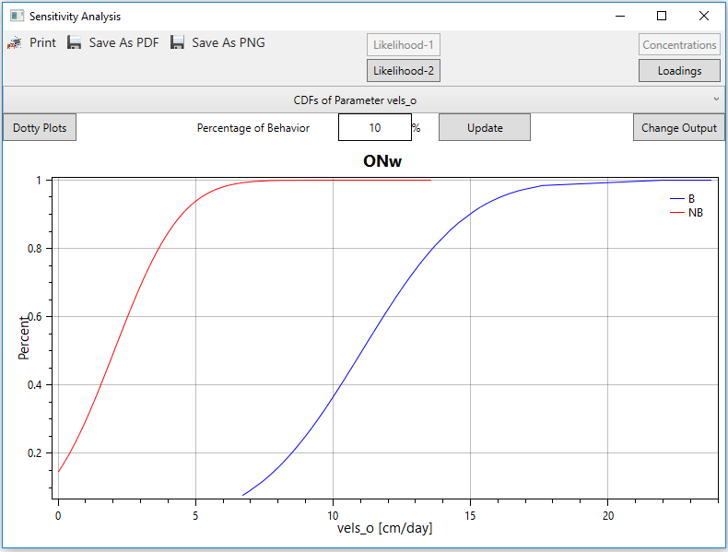

Figure 3.82

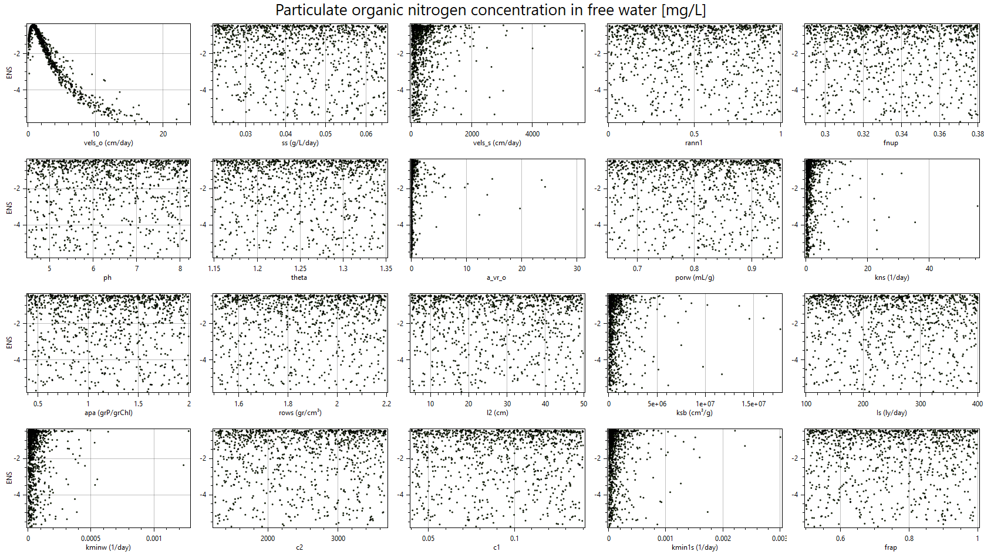

Figure 3.83

#### Uncertainty Analysis with BMCML

Post-processing for the stochastic model can also conduct a Bayesian Monte Carlo simulation and maximum likelihood estimation analysis (BMCML). This approach combines Bayesian Monte Carlo (BMC) simulation (e.g., Dilks et al. 1992) with the maximum likelihood estimation and borrows the concept of “equifinality” from the GLUE methodology, i.e. the emphasis is placed on the generated parameter sets.

In BMCML, the maximum likelihood value is obtained from $\hat{l}$ ( $θ_{i})={(2πe{\hat{σ}}_{εi}^{2})}^{-\frac{m}{2}}$ where ${\hat{σ}}_{εi}^{2}$ is the variance of model structural error which is calculated by $σ_{ε}^{2}=\frac{σ_{w}^{2}}{1-ρ^{2}}$ in which $σ_{ω}^{2}$ is the variance of residual errors. Users are referred to Hantush and Chaudhary (2014) and Chaudhary and Hantush (2017) for details about the BMCML method.

The Bayesian estimate of each model output concentration *Y* at any point in time is the conditional mean of *Y* given the observation *O*, $E\left(Y | O\right)$ which in the discrete form can be approximated (assuming uniformly sampled parameter space) as (Hantush and Chaudhary 2014):

$$E\left(Y | O\right)=\sum_{i=1}^{n}{E\left(Y | θ_{i}\right)P\left(θ_{i} | O\right)=\sum_{i=1}^{n}{C(θ_{i})P\left(θ_{i} | O\right)}}$$

where $C(θ_{i})$ is model simulated output and $P\left(θ_{i} | O\right)$ is the posterior probability mass of parameter set $θ_{i}={(θ_{1}^{i},θ_{2}^{i}, …,θ_{r}^{i} )}^{T}$.

The explicit expression for the posterior CDF of the model parameters and the expressions used to construct predictions (i.e., median and confidence limits) for future observed values of *Y* given the observed records, *O*, is (Hantush and Chaudhary 2014):

$$E\left(Y | O\right)=\frac{1}{2}+\frac{1}{2}\sum_{i=1}^{n}{erf\left(\frac{y-C(θ_{i})-{\hat{μ}}_{i}}{\sqrt{2}{\hat{σ}}_{ε}}\right)P\left(θ_{i} | O\right)}$$

where ${\hat{μ}}_{i}$ is the mean of residual errors. Users are referred to Hantush and Chaudhary (2014) and Chaudhary and Hantush (2017) for details about the BMCML method.

Similar to the uncertainty analysis with GLUE in Section 3.6.4.1, the joint likelihood of immediate parent constituents is used in BMCML analysis if there is no observed data for the constituent under study.

Under Post-processing>BMCML menu, in order to plot priori/posterior the cumulative distribution functions (CDFs) and the probability density functions (PDFs), the Prediction Bands and Posterior CDFs and PDFs sub-menus are available for the user as shown in Figure 3.84. When the user clicks the Post-processing>BMCML>Prediction Bands menu, the BMCML (Prediction Bands) window will be displayed (Figure 3.85). The user has the option of selecting either “Loadings” or “Concentrations” by clicking the Loadings or Concentrations button. Results will be displayed based on the selection. The default is “Concentrations” and selected unit type is activated, and vice versa. By clicking the “Select Output” bar, the user can select the desired constituent under the bar as shown in Figure 3.86.

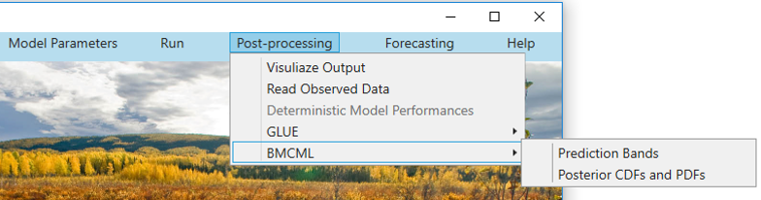

Figure 3.84

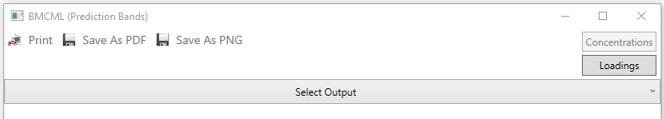

Figure 3.85

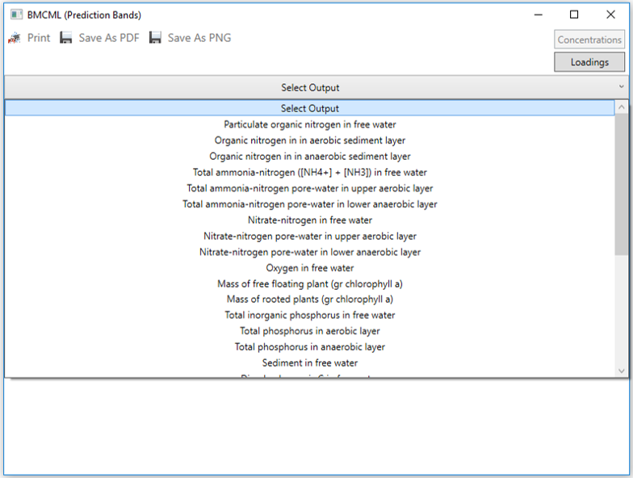

Figure 3.86

Figure 3.87 and Figure 3.88 displays the prediction bands and performances for Organic nitrogen (*Onw*) based on loadings. Again, if observed data are flow-weighted average of a certain number of days, the GUI will plot the results only for those periods with no time association. Users can also see the plot for the daily output by clicking the Daily Period. See GLUE section for detail.

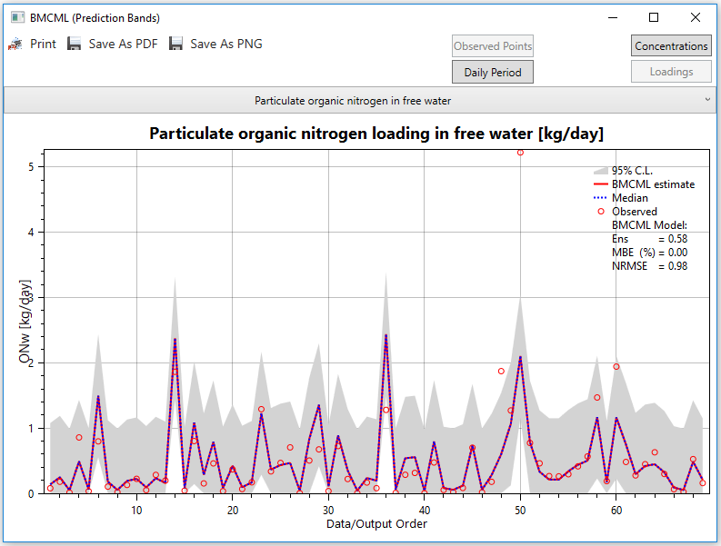

Figure 3.87

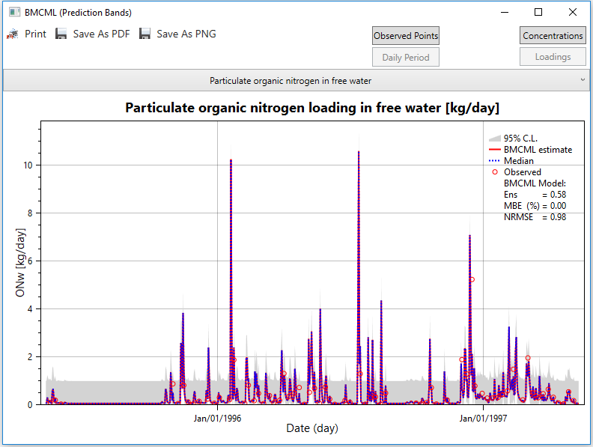

Figure 3.88

Both loadings (Figure 3.87 and Figure 3.88) and concentrations (Figure 3.89 and Figure 3.90) of observed and simulated values can be used in the BMCML calculations. The user can visualize loading or concentration results by simply clicking Loadings or Concentrations buttons, respectively.

As explained in section 3.6.4.1, if observed data are daily or instantaneous values, the GUI will plot BMCML results in a continuous time scale as shown in Figure 3.88 and Figure 3.90. If observed data are flow-weighted average of a certain number of days, the GUI will plot BMCML results for those periods only, with no time association (Figure 3.87 and Figure 3.89).

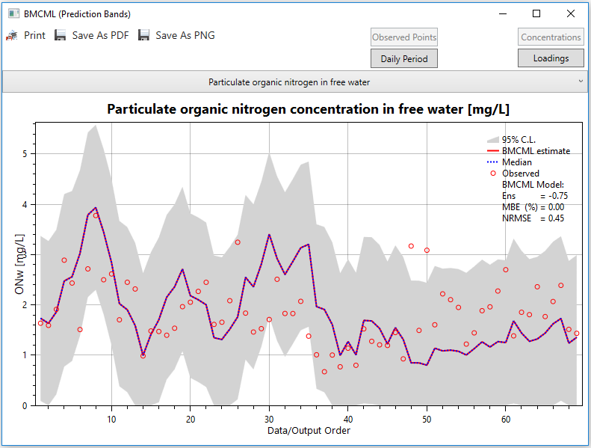

Figure 3.89

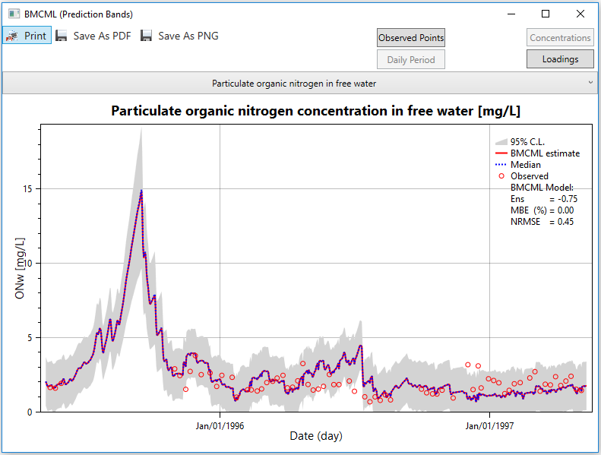

Figure 3.90

#### Posterior CDFs and PDFs

Under the Post-processing>BMCML menu, when the Posterior CDFs and PDFs sub-menu is clicked, the Posterior Analysis window is displayed as shown in Figure 3.91. The user needs to select a constituent under the “Select Output” bar and click “Start Calculation” in order to calculate posterior CDFs and PDFs (Figure 3.92) (refer to Hantush and Chaudhary, 2014 and Chaudhary and Hantush, 2017). It takes several minutes or a couple of hours depending on the number of simulations and the length of the period. After calculations are completed, the CDF and PDF graphs of the 20 most effective parameters can be visualized by selecting a parameter under the selected constituent bar. The default percentage rate is displayed on the window. The user can change the rate to any value between 1-10%. When the user clicks the “Update” button, calculations will be repeated based on the selected new percentage rate. If the user needs to select another constituent, the “Change Output” button should be clicked. Figure 3.93 and Figure 3.94 display priori and posterior CDFs and PDFs for NO3w. When the user clicks the “CDF” and “PDF” buttons on the right upper side, the user can visualize CDF and PDF graphs, sequentially.

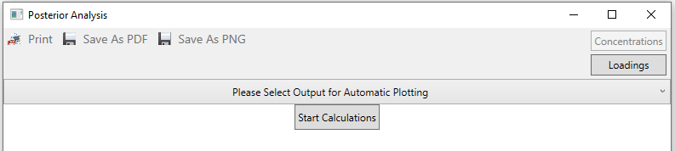

Figure 3.91

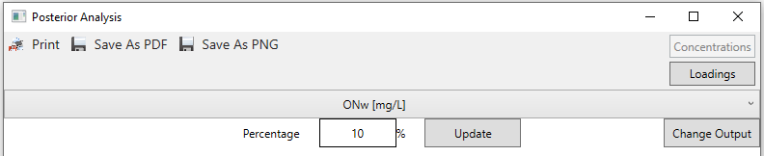

Figure 3.92

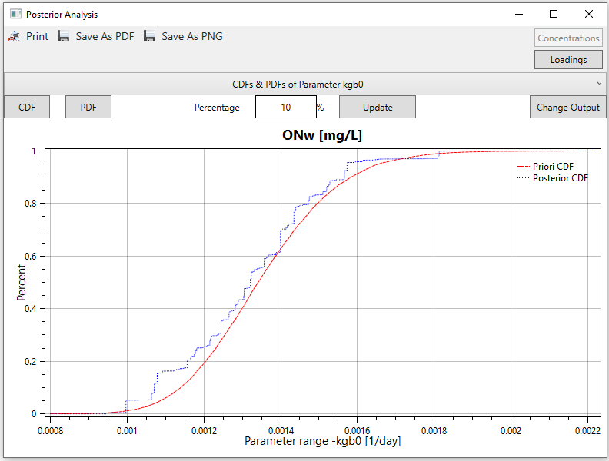

Figure 3.93

The user has always “Print” and “Save As” (in PDF and PNG format) options for all graph windows using the buttons on the top bar.

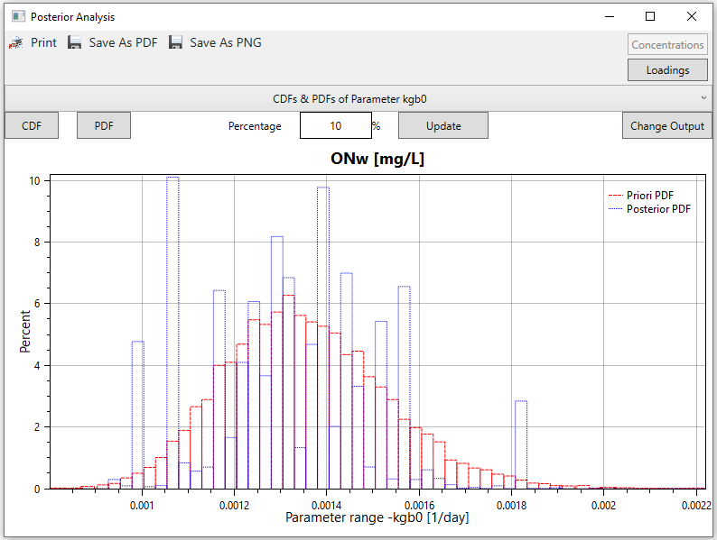

Figure 3.94

## Forecasting/Validation

After analyzing the results of the simulation(s) for a given period, the GUI activates the forecasting option. With this, the model can be run for a future period or any time span to forecast or validate data using the generated model parameter values and associated likelihood values of the main project. The Forecasting/Validation window is displayed when the user clicks the Forecasting>Start Forecasting/Validation menu as shown in Figure 3.95 and Figure 3.96. After clicking the Forecasting>Start Forecasting/Validation menu, the GUI will copy all input files with sub-directories to the “Forecast” folder under the main project folder.

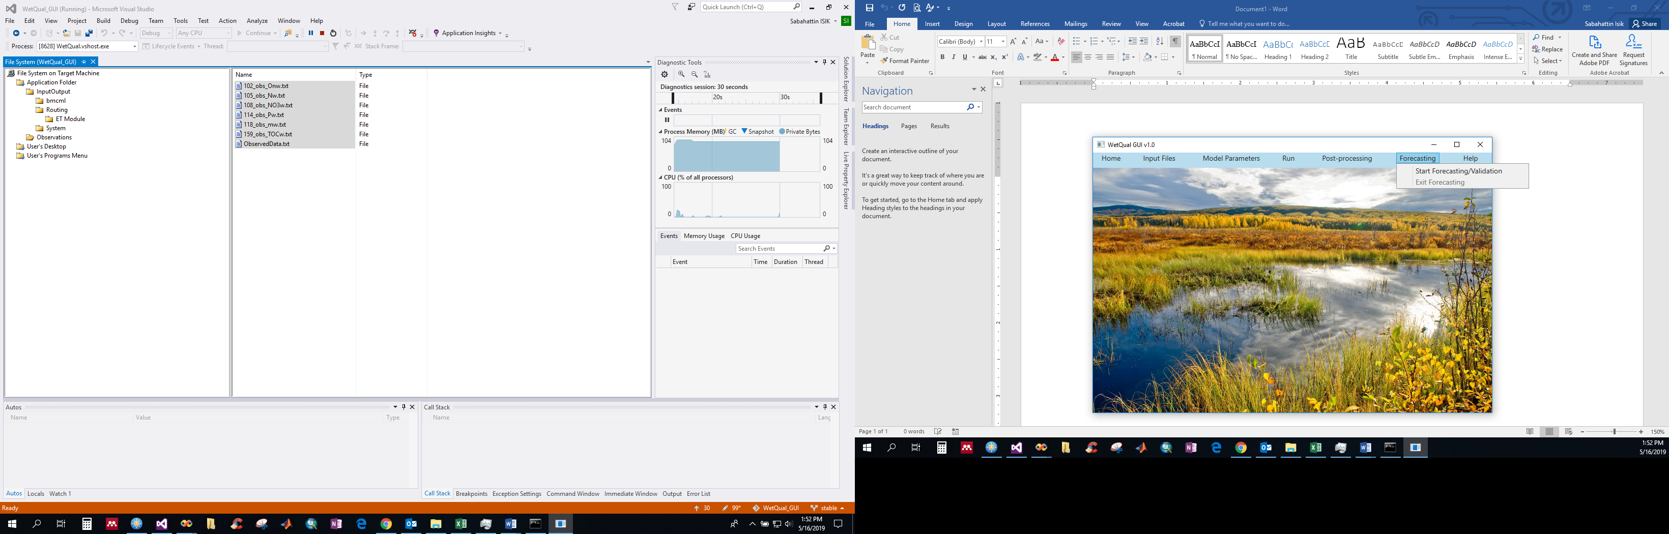

Figure 3.95

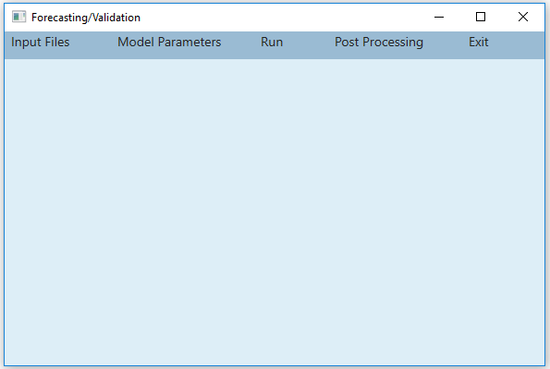

Figure 3.96

The procedures in Section 3.3 should be repeated for the forecasting period to prepare input files (Figure 3.97). Since the input files used in the main project simulation are copied under the >Forecast>InputOutput folder, the user can select related files under this folder and make necessary changes. Since the GUI will use the likelihood values of the generated nitrogen and carbon parameters from the main project, the user is not allowed to change the stochastic model parameters. The Model Parameters>Stochastic Model command (Figure 3.98) loads the parameters of the main project. On the other hand, users can also run *WetQual* in a deterministic model by selecting one of the parameter sets. The Model Parameters>Deterministic Model menu (Figure 3.98) lets the user set the model parameter values as described in Section 3.4. If users want to run *WetQual* with a particular parameter set from the generated set of parameters (for example, the one that had the highest likelihood value), they can do the following:

* Open the file “*14_generated_parameters.txt*” under the main project **InputOutput** folder and copy the row that has the desired parameter set (Figure 3.99).
* Open the file “*14_generated_parameters.txt”* under the **Forecast\** **InputOutput** folder and paste the copied parameter values (Figure 3.100)*.*
* Repeat the same procedure for the carbon parameters*.*

After completing input files, select the Run >Run WetQual menu to run the *WetQual* for forecasting period (Figure 3.101).

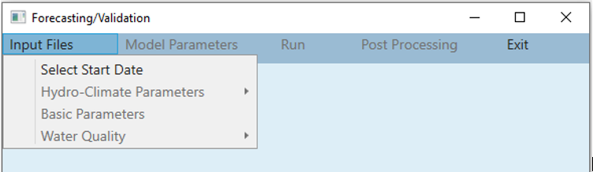

Figure 3.97

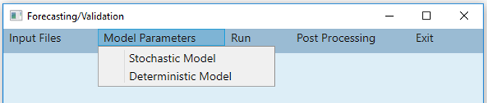

Figure 3.98

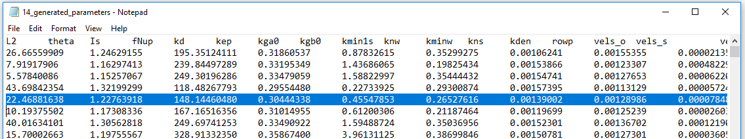

Figure 3.99

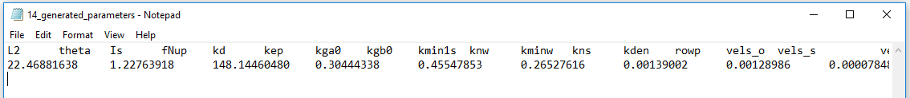

Figure 3.100

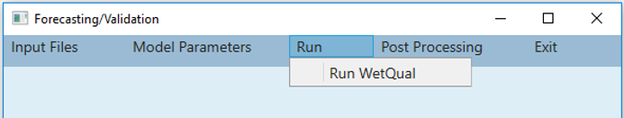

Figure 3.101

The user can visualize the results as described in Section 3.6.1 using the Visualize Output menu. If the observed data are available for the forecasting period (validation period can be run under forecasting option), the results can be used for validation purposes. In this case, the user needs to select observed files using the Read Observed Data sub-menu as described in Section 3.6.2 (Figure 3.102). If the forecasting model is run with the whole parameter set (Stochastic mode), under the Post-processing menu, the “Deterministic Model Performances” menu is deactivated and the GLUE and BMCML menus are activated or vice versa (Figure 3.102). The function of GLUE and BMCML menus in the Forecasting window are similar to the functions of the GLUE>Sensitivity Analysis and BMCML>Prediction Bands menus as described in Sections 3.6.4.1 and 3.6.4.3. The GLUE menu displays the GLUE window as shown in Figure 3.103. The prediction band is displayed after a constituent is selected (Figure 3.104 and Figure 3.105). Prediction bands can be displayed for different likelihood functions based on concentrations and loadings by clicking the Likelihood-1 or Likelihood-2 and Concentrations or Loadings buttons, respectively.

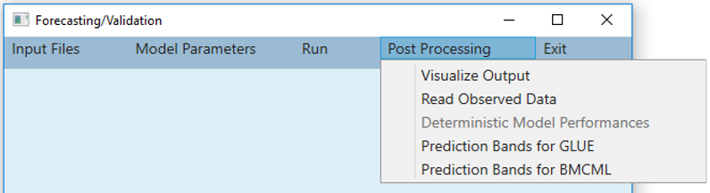

Figure 3.102

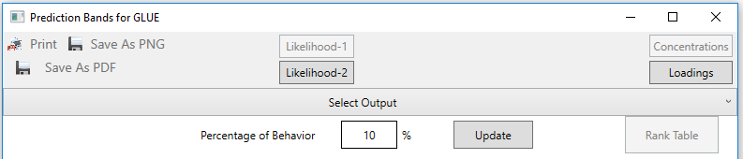

Figure 3.103

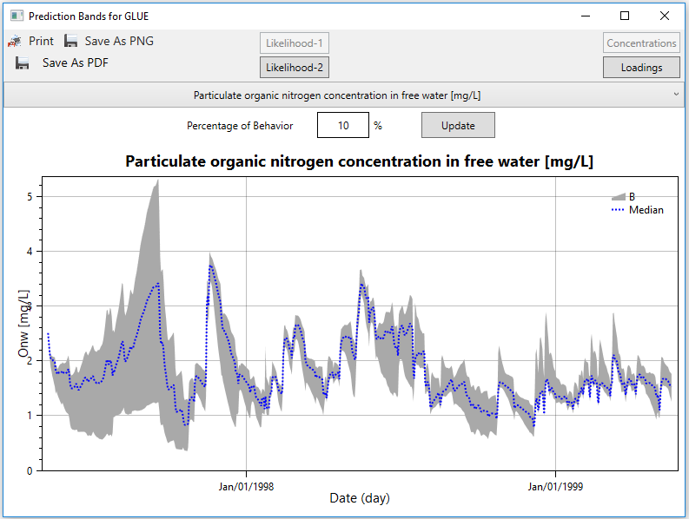

Figure 3.104

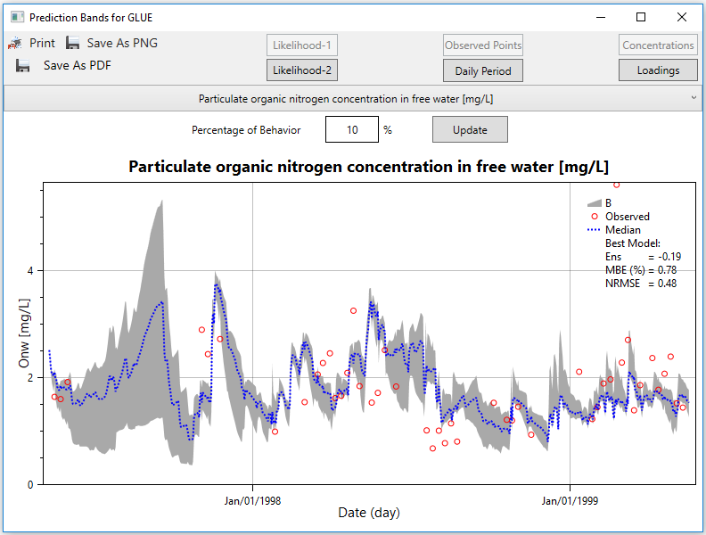

Figure 3.105

The BMCML menu opens the BMCML window as shown in Figure 3.106. The BMCML prediction band is displayed after selecting a constituent (Figure 3.107). The user has the option to select either “Loadings” or “Concentrations” to work with. The calculations are based on the BMCML likelihood values of the main project. If the observed data are available for the projected period, the performance values are also displayed beside the band on the window as shown in

Figure 3.108.

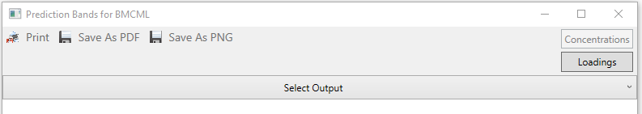

Figure 3.106

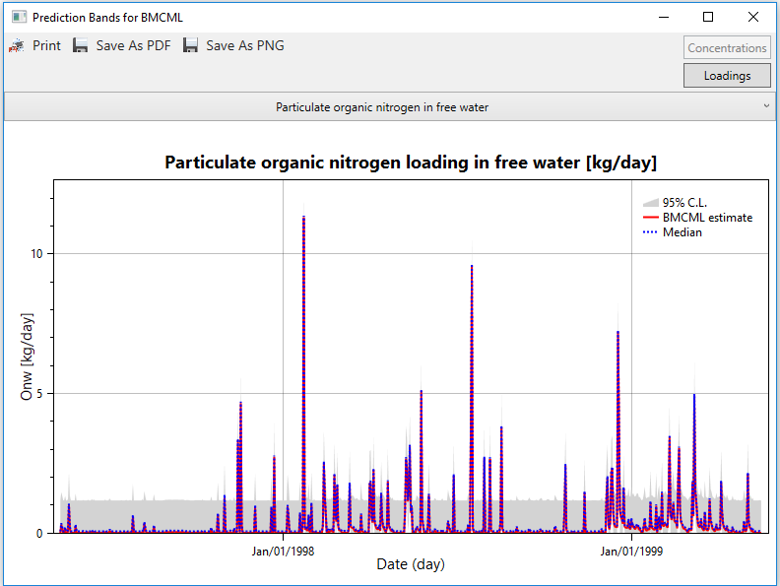

Figure 3.107

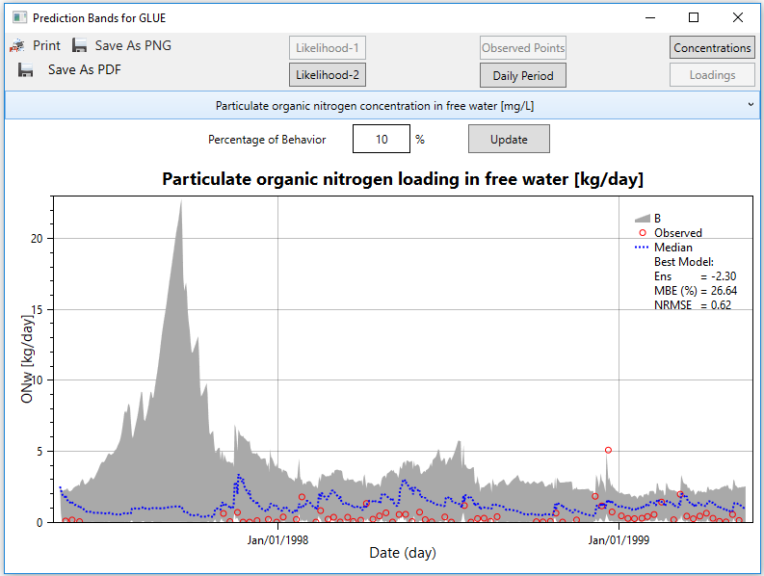

Figure 3.108

## Help

The Help menu provides the user with quick access to the “User Manual” of the *WetQual* GUI. It also provides some information about the contributors for the development of *WetQual* GUI on the About page. The user can find some key papers for *WetQual* model (Hantush et al., 2013; Kalin et al., 2013; Sharifi et al., 2013), GLUE methodology (Beven and Binley,1992 and Beven and Freer, 2001), and BMCML methodology (Hantush and Chaudhary, 2014 and Chaudhary and Hantush, 2017) under **Help>Publications** menu (Figure 3.109).

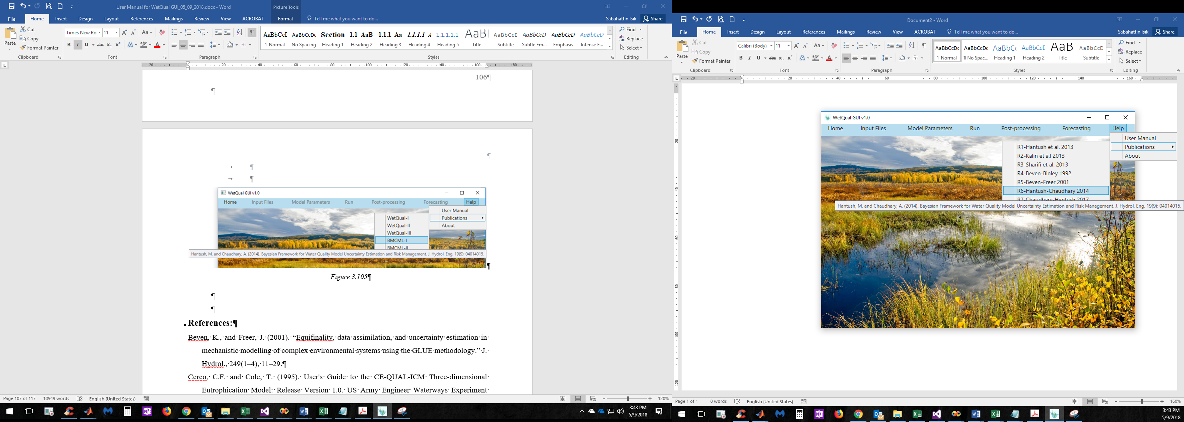

Figure 3.109

# References:

Beven, K. and Binley, A. (1992). The future of distributed models: Model calibration and uncertainty prediction. Hydrol. Processes, 6, 279–298.

Beven, K., and Freer, J. (2001). “Equifinality, data assimilation, and uncertainty estimation in mechanistic modeling of complex environmental systems using the GLUE methodology.” J. Hydrol., 249(1–4), 11–29.

Cerco, C.F. and Cole, T. (1995). User's Guide to the CE-QUAL-ICM Three-dimensional Eutrophication Model: Release Version 1.0. US Army Engineer Waterways Experiment Station.

Chapra, S.C. (1997). Surface water-quality modeling. McGraw-Hill New York.

Chaudhary, A. and Hantush, M. (2017). “Bayesian Monte Carlo and maximum likelihood approach for uncertainty estimation and risk management: Application to lake oxygen recovery model.” Water Research, 108 (2017): 301–311.

Chow, V. T., Maidment, D. R., and Mays, L. W. (1988). Applied hydrology. McGraw-Hill Series in Water Resources & Environmental Engineering. 572 pages.

Di Toro, D.M. (2001). Sediment flux modeling. Wiley-Interscience New York.

Hamon, W.R. (1961). “Estimating potential evapotranspiration.” Journal of Hydraulics Division, Proceedings of the American Society of Civil Engineers 871: 107–120.

Hantush, M., Kalin, L., Isik, S., and Yucekaya, A. (2013) “Nutrient Dynamics in Flooded Wetlands. I: Model Development.” J. Hydrol. Eng., 18(12), 1709–1723.

Hantush, M. and Chaudhary, A. (2014). "Bayesian Framework for Water Quality Model Uncertainty Estimation and Risk Management." J. Hydrol. Eng., 10.1061/(ASCE)HE.1943-5584.0000900, 04014015.

Ji, Z.-G. (2008). Hydrodynamics and water quality: modeling rivers, lakes, and estuaries. Wiley-Interscience.

Kalin, L., Hantush, M., Isik, S., Yucekaya, A., and Jordan, T. (2013). "Nutrient Dynamics in Flooded Wetlands. II: Model Application." J. Hydrol. Eng., 18(12), 1724-1738.

Reddy, K.R. and DeLaune, R.D. (2008). “Biogeochemistry of wetlands: science and applications.” 1 ed. CRC Press, Taylor & Francis Group, Boca Raton, FL.

Schnoor, J.L. (1996). “Environmental modeling: fate and transport of pollutants in water, air, and soil.” John Wiley and Sons.

Sharifi, A., Kalin, L., Hantush, M.M., Isik, S., and Jordan, T.E. (2013). “Carbon dynamics and export from flooded wetlands: a modeling approach.” Ecol. Modell. 263, 196–210.

Stefan, H.G. and Preud’homme, E.B. (1993). “Stream temperature estimation from air temperature.” Water Resources Bulletin, 29, 27–45.

# Appendix: Definitions for Input files, parameters and output files of *WetQual*

Table A. 1A short description of *WetQual* subroutines

| **Subroutine name** | **Fortran file** | **Short definition** |
| --- | --- | --- |
| InOutTXT | 2.1-InOutTXT.f90 | To read master file and to create the text files to output the results. |
| FixedInitial | 2.2-FIXEDINITIAL.f90 | To read the basic model parameters, initial concentrations of nutrients, hydro-climate, and input concentration time series. |
| ReadParms | 2.3-Parms-Calc.f90 | To read some of the WetQual parameters which are considered to be random. |
| Equal0 | 2.4-Neg-EqZero.f90 | To check the calculated outputs for non-negativity. |
| OxyPlant | 3.0-Plant-Oxygen.f90 | To calculate sediment oxygen demand (SOD) and oxygen in the water column as well as the mass of floating plant. |
| Nitrogen | 3.1-Nitrogen.f90 | To simulate nitrogen transformation and removal in three layers including water column, aerobic and anaerobic soil layers. |
| PhosphorSed | 3.2-Phos-sed.f90 | To simulate phosphorus and sediment processes in wetlands. |
| Carbon | 3.3-Carbon.f90 | To simulate carbon cycle and removal in wetlands. |
| Printresults | 5-PrintResults.f90 | To print the WetQual outputs. |

Table A. 2 Hydro-Climate Parameters (“12_hydro_climate.txt” file)

| **Symbol** | **Definition, Units** |
| --- | --- |
| *Qin* | Volumetric inflow rate (m3/day) |
| *Q*out | Wetland discharge (outflow) rate (m3/day) |
| *Vw* | Water volume of wetland surface water (m3) |
| *A* | wetland surface area (m2) |
| *ET* | Evapotranspiration rate (cm/day) |
| *ip* | Precipitation rate (cm/day) |
| *Qg* | Groundwater discharge (negative for infiltration) (m3/day) |
| *U*w | Wind speed (m/s) |
| *T*water | Daily water temperature (°C) (note that the users have an option to calculate *T*water if they have daily air temperature (*T*air) available) |

Table A. 3 Basic Parameters (“10_basic_parameters.txt” file)

| **Symbol** | **Definition, Units** |
| --- | --- |
| *dt* | Timestep of simulation (day) |
| *n* | Number of days of simulation |
| *ronn* | Gram of oxygen consumed per gram of total ammonium nitrogen nitrified (g*O*/g*N*) |
| *rond* | Gram of oxygen consumed per gram of organic nitrogen mineralized(g*O*/g*N*) |
| *roc* | Gram of oxygen produced per gram of organic carbon synthesized |
| *sims* | Number of Monte Carlo (MC) simulations |
| *fNw* | Fraction of mineral nitrogen plant uptake as nitrate-N in free water |
| *fNs1* | Fraction of mineral nitrogen plant uptake as nitrate-N in the aerobic layer |
| *fNs2* | Fraction of mineral nitrogen plant uptake as nitrate-N in the anaerobic layer |
| *fNO3w* | Fraction of mineral nitrogen plant uptake as nitrate-N in free water |
| *fNO3s1* | Fraction of mineral nitrogen plant uptake as nitrate-N in the aerobic layer |
| *fNO3s2* | Fraction of mineral nitrogen plant uptake as nitrate-N in the anaerobic layer |
| *apn* | Phosphorus to nitrogen mass ratio produced by mineralization of particulate organic matter (POM) |
| *lat* | latitude in radians |
| *amc* | Stoichiometric yield of Methane from the anaerobic decomposition of gram of organic carbon during methanogenesis (gr/gr) |
| *lamdaR* | Specific conductivity of root system (m root m-3 soil) |
| *dn* | Day number of the year (day), Julian day |

Note that “*n*” and “*d*n” parameters are updated automatically when the user picks and views the “Hydro-Climate Parameters”. Also, the “*sims*” parameter will be automatically updated when the user chooses between Deterministic and Stochastic modes. So, the access to these three parameters from “Basic Parameters” window has been limited. Users can access them in “10_fixed_parameters.txt” file from “InputOutput” folder but it is recommended not to change values of parameter values from that file. Users can control all the required parameters directly from the “Basic Parameter” window.

Table A. 4 Initial Concentration (“11_initial_concentration.txt” file)

| **Symbol** | **Definition, Units** |
| --- | --- |
| *Onw* | Particulate organic nitrogen concentration in free water (mg/L) |
| *Onss* | Concentration of refractory organic nitrogen in wetland soil (mg/L) |
| *Onsf* | Concentration of labile organic nitrogen in wetland soil (mg/L) |
| *Nw* | Total ammonia-nitrogen ([*NH4*+] + [*NH3*]) concentration in free water (mg/L) |
| *Ns1* | Total ammonia-nitrogen pore-water concentration in upper aerobic layer (mg/L) |
| *Ns2* | Total ammonia-nitrogen pore-water concentration in lower anaerobic layer (mg/L) |
| *NO3w* | Nitrate-nitrogen concentration in free water (mg/L) |
| *NO3s1* | Nitrate-nitrogen pore-water concentration in upper aerobic layer (mg/L) |
| *NO3s2* | Nitrate-nitrogen pore-water concentration in lower anaerobic layer (mg/L) |
| *a* | Mass of free-floating plant (gr chlorophyll a) |
| *b* | Mass of rooted plants (gr chlorophyll a) |
| *mw* | Sediment concentration in free water (mg/L) |
| *ms* | Wetland soil bulk density (mg/L) |
| *Ow* | Oxygen concentration in free water (mg/L) |
| *Pw* | Total inorganic phosphorus concentration in free water (mg/L) |
| *Ps1* | Total phosphorus concentration in aerobic layer (mg/L) |
| *Ps2* | Total phosphorus concentration in anaerobic layer (mg/L) |
| *DOCw* | Concentrations of dissolved organic C in free water (mg/L) |
| *LPOCw* | Concentrations of labile (fast-reacting) particulate organic C in free water (mg/L) |
| *RPOCw* | Concentrations of refractory (slow reacting) particulate organic C in free water (mg/L) |
| *DOCs1* | Pore water concentrations of *DOC* in aerobic sediment layer (mg/L) |
| *LPOCs1* | Pore water concentrations of *LPOC* in aerobic sediment layer (mg/L) |
| *RPOCs1* | Pore water concentrations of *RPOC* in aerobic sediment layer (mg/L) |
| *DOCs2* | Pore water concentrations of *DOC* in lower anaerobic sediment layer (mg/L) |
| *LPOCs2* | Pore water concentrations of *LPOC* in lower anaerobic sediment layer (mg/L) |
| *RPOCs2* | Pore water concentrations of *RPOC* in lower anaerobic sediment layer (mg/L) |
| *CH4w* | Methane concentration in free water (mg/L) |
| *CH4s1* | Methane concentration in aerobic sediment layer (mg/L) |
| *CH4s2* | Methane concentration in anaerobic sediment layer (mg/L) |

Table A. 5 Input Concentrations (“13_input_concentrations.txt” file)

| **Symbol** | **Definition, Units** |
| --- | --- |
| *ONin* | Organic nitrogen concentration in incoming flow (mg/L) |
| *NO3in* | Nitrate-nitrogen concentration in incoming flow (mg/L) |
| *NWin* | Total ammonia-nitrogen ([*NH4*+] + [*NH3*]) concentration in incoming flow (mg/L) |
| *NO3g* | Nitrate-nitrogen concentration in groundwater discharge (mg/L) |
| *Ng* | Total ammonia-nitrogen concentration in groundwater discharge (mg/L) |
| *Owin* | Oxygen concentration in incoming flow (mg/L) |
| *PO4in* | Phosphate concentration in incoming flow (mg/L) |
| *Pg* | Total phosphorus concentration in groundwater discharge (mg/L) |
| *mwin* | Sediment concentration in incoming flow (mg/L) |
| *NH4air* | Ammonium concentration in precipitation (mg/L) |
| *NO3air* | Nitrate-nitrogen concentrations in precipitation (mg/L) |
| *Qa* | Dry depositional rates of total ammonia nitrogen (mg/m2/day) |
| *Qn* | Dry depositional rates of total nitrate-nitrogen (mg/m2/day) |
| *LPOCin* | Labile particulate organic carbon concentration in incoming flow (mg/L) |
| *RPOCin* | Refractory particulate organic carbon concentration in incoming flow (mg/L) |
| *DOCin* | Dissolved organic carbon concentration in incoming flow (mg/L) |
| *DOCatm* | Atmospheric deposition for total organic carbon (mg/m2/day) |
| *TOCgw* | Total organic carbon concentration in groundwater discharge (mg/L) |

Table A. 6 Definition of WetQual Outputs

| **Output file Name** | **Symbol** | **Definition, Units** |
| --- | --- | --- |
| *102_obs_Onw.txt* | *Onw* | Particulate organic nitrogen concentration in free water (mg/L) |
| *103_obs_Onss.txt* | *Onss* | Concentration of refractory organic nitrogen in wetland soil (mg/L) |
| *104_obs_Onsf.txt* | *Onsf* | Concentration of labile organic nitrogen in wetland soil (mg/L) |
| *105_obs_Nw.txt* | *Nw* | Total ammonia-nitrogen ([*NH4*+] + [*NH3*]) concentration in free water (mg/L) |
| *106_obs_Ns1.txt* | *Ns1* | Total ammonia-nitrogen pore-water concentration in upper aerobic layer (mg/L) |
| *107_obs_Ns2.txt* | *Ns2* | Total ammonia-nitrogen pore-water concentration in lower anaerobic layer (mg/L) |
| *108_obs_NO3w.txt* | *NO3w* | Nitrate-nitrogen concentration in free water (mg/L) |
| *109_obs_NO3s1.txt* | *NO3s1* | Nitrate-nitrogen pore-water concentration in upper aerobic layer (mg/L) |
| *110_obs_NO3s2.txt* | *NO3s2* | Nitrate-nitrogen pore-water concentration in lower anaerobic layer (mg/L) |
| *111_obs_Ow.txt* | *Ow* | Oxygen concentration in free water (mg/L) |
| *112_obs_a.txt* | *a* | Mass of free-floating plant (gr chlorophyll a) |
| *113_obs_b.txt* | *b* | Mass of rooted plants (gr chlorophyll a) |
| *114_obs_Pw.txt* | *Pw* | Total inorganic phosphorus concentration in free water (mg/L) |
| *115_obs_Ps1.txt* | *Ps1* | Total phosphorus concentration in aerobic layer (mg/L) |
| *116_obs_Ps2.txt* | *Ps2* | Total phosphorus concentration in anaerobic layer (mg/L) |
| *118_obs_mw.txt* | *mw* | Sediment concentration in free water (mg/L) |
| *150_obs_DOCw.txt* | *DOCw* | Concentrations of dissolved organic C in free water (mg/L) |
| *151_obs_LPOCw.txt* | *LPOCw* | Concentrations of labile (fast-reacting) particulate organic C in free water (mg/L) |
| *152_obs_RPOCw.txt* | *RPOCw* | Concentrations of refractory (slow reacting) particulate organic *C* in free water (mg/L) |
| *153_obs_DOCs1.txt* | *DOCs1* | Pore water concentrations of *DOC* in aerobic sediment layer (mg/L) |
| *154_obs_LPOCs1.txt* | *LPOCs1* | Pore water concentrations of *LPOC* in aerobic sediment layer (mg/L) |
| *155_obs_RPOCs1.txt* | *RPOCs1* | Pore water concentrations of *RPOC* in aerobic sediment layer (mg/L) |
| *156_obs_DOCs2.txt* | *DOCs2* | Porewater concentrations of *DOC* in lower anaerobic sediment layer (mg/L) |
| *157_obs_LPOCs2.txt* | *LPOCs2* | Porewater concentrations of *LPOC* in lower anaerobic sediment layer (mg/L) |
| *158_obs_RPOCs2.txt* | *RPOCs2* | Porewater concentrations of *RPOC* in lower anaerobic sediment layer (mg/L) |
| *159_obs_TOCw.txt* | *TOCw* | Concentrations of total organic *C* in free water (mg/L) |
| *160_obs_CH4w.txt* | *CH4w* | Methane concentration in free water (mg/L) |
| *161_obs_CH4s1.txt* | *CH4s1* | Methane concentration in aerobic sediment layer (mg/L) |
| *162_obs_CH4s2.txt* | *CH4s2* | Methane concentration in anaerobic sediment layer (mg/L) |

Table A. 7 N, P, TSS parameters (“14_generated_parameters.txt” file)

| **Symbol in publications** | **Symbols in the model files** | **Definition, Units** |
| --- | --- | --- |
| *l*2 | *L2* | Thickness of anaerobic soil layer (cm) |
| *θ* | *theta* | Temperature coefficient in Arhenious equation |
| *Is* | *Is* | Optimal light level (ly/day), range from about 100 to 400 ly/d (Chapra, 1997, p. 611) |
| *f*N | *fNup* | Fraction of total ammonia nitrogen in ionized form |
| *kd* | *Kd* | Ammonium ion distribution coefficient (mL/g) |
| *kep* | *kep* | Parameter required as input but not used in the model (1/m) |
| *kga* | *kga0* | Growth rate of free-floating plant (1/day) |
| *kgb* | *kgb0* | Growth rate of benthic and rooted plant (1/day) |
| *kmr* | *kmin1s* | First-order rapid mineralization rate in wetland soil (1/day) |
| *knw* | *knw* | First-order nitrification rate in wetland free water (1/day) |
| *kmw* | *kminw* | First-order mineralization rate in wetland free water (1/day) |
| *kns* | *kns* | First-order nitrification rate in aerobic soil layer (1/day) |
| *kdn* | *kden* | Denitrification rate in anaerobic soil layer (1/day) |
| ρ*s* | *rows* | Wetland soil particle density (g/cm3) |
| *vso* | *vels_o* | Effective settling velocity (cm/day) for organic material |
| *vss* | *vels_s* | Effective settling velocity (cm/day) for sediment |
| *vb* | *velb* | Effective burial velocity (cm/day) |
| *ana* | *ana* | Gram of nitrogen per gram of chlorophyll-a in plant/algae (gN/gChl) |
| *rc,chl* | *rChl* | Ratio of carbon mass to chlorophyll a mass in algae (gC/gChl) |
| *Ss* | *Ss* | Oxygen removal rate per unit volume of aerobic layer by other processes (g/L/day) |
| *Sw* | *Sw* | Volumetric oxygen consumption rate in water by other processes (gr/cm3/day) |
| *α* | *c_uw* | Empirical parameter used for calculating volatilization mass transfer velocity kv |
| *fr* | *frap* | Fraction of rapidly mineralizing particulate organic matter |
| *c1* | *c1* | Used for calculating pK (Keq, equilibrium coefficient) |
| *c2* | *c2* | Used for calculating pK (Keq, equilibrium coefficient) |
| *pH* | *PH* | pH |
| *S* | *S* | Rate of nitrogen fixation by microorganisms (mg-N/m3/hr) |
| *Kw* | *Kw* | Phosphorus sorption coefficient in water (cm3/g) |
| **pa | *apa* | Ratio of phosphorus to Chlorophyll-a in algae (grP/grChl) |
| *Dpw* | *Dpw* | Inorganic phosphorus free-water diffusion coefficient (cm2/day) |
| *Ksa* | *Ksa* | Accounts for partitioning to phosphorus sorption site (cm3/g) |
| *Ksb* | *Ksb* | Accounts for association with iron hydroxide precipitate (cm3/g) |
| *Ran1* | *Ran1* | Random number used for calculating soil porosity (φ) and free-water oxygen diffusion coefficient |
| *fw* | *fW* | Fraction of nitrogen fixation in water |
| *fact* | *fact* | Vertical diffusion magnification factor |
| *ro* | *alfa_velr_o* | Coefficient for resuspension/recycling of organic material |
| *rs* | *alfa_velr_s* | Coefficient for resuspension/recycling of sediment |
| *φw* | *porw* | Effective porosity of wetland surface water |

Table A. 8 Carbon parameters (“15_generated_parameters_carbon.txt” file)

| **Symbol in publications** | **Symbols in the model files** | **Definition, Units** |
| --- | --- | --- |
| *aca* | *aca* | Ratio of carbon to chlorophyll-a in algae (gC/gChl) |
| $$f_{aD}$$ | *FaDOC* | Fraction of dissolved organic C produced by death/loss of free-floating plants and attached algae (*faL* + *faR*+ *faD*= 1) (Dimensionless) |
| $$f_{aL}$$ | *FaLPOC* | Fraction of labile particulate C produced by death/loss of free-floating plants and attached algae (*faL* + *faR*+ *faD* = 1) (Dimensionless) |
| $$f_{aR}$$ | *FaRPOC* | Fraction of refractory particulate C produced by death/loss of free floating plants and attached algae (*faL* + *faR*+ *faD* = 1) (Dimensionless) |
| $$f_{bD}$$ | *FbDOC* | Fraction of dissolved organic C produced by death/loss of rooted and benthic plants (*fbL* + *fbR*+ *fbD*= 1) |
| $$f_{bL}$$ | *FbLPOC* | Fraction of labile particulate C produced by death/loss of rooted and benthic plants (*fbL* + *fbR*+ *fbD* = 1) |
| $$f_{bR}$$ | *FbRPOC* | Fraction of refractory particulate C produced by death/loss of rooted and benthic plants (*fbL* + *fbR*+ *fbD* = 1) |
| $$k_{L}$$ | *kLPOC* | First-order hydrolysis rate of labile particulate organic carbon (1/day) |
| $$k_{R}$$ | *kRPOC* | First-order hydrolysis rate of refractory particulate organic carbon (1/day) |
| $$K_{O}$$ | *KsatO* | Michaelis–Menten half-saturation concentration of dissolved oxygen required for oxic respiration (mg/L) |
| $$K_{O}^{in}$$ | *KinO* | Michaelis–Menten oxygen inhabitation coefficient (mg/L) |
| $$K_{N}$$ | *KN* | Michaelis–Menten nitrate N half-saturation concentration required for denitrification (mg/L) |
| $$K_{N}^{in}$$ | *KinN* | Michaelis–Menten nitrate-N inhibition coefficient (mg/L) |
| $$k_{D}^{1}$$ | *K1DOC* | Maximum dissolved organic C utilization rate for aerobic respiration (1/day) |
| $$k_{D}^{2}$$ | *k2DOC* | Maximum dissolved organic C utilization rate for denitrification (1/day) |
| $$k_{D}^{3}$$ | *k3DOC* | Maximum dissolved organic C utilization rate for methanogenesis in anaerobic water (1/day) |
| $$k_{D}^{4}$$ | *k4DOC* | Maximum dissolved organic C utilization rate for methanogenesis in anaerobic sediment (1/day) |
| *cp1* | *cp1* | Fraction of inflowing organic carbon (*TOCin*) in the form of dissolved organic carbon (*DOC*) |
| *Cp2* | *cp2* | Fraction of inflowing organic carbon in the form of labile particulate organic carbon (*LPOC*) |
| *Cp3* | *cp3* | Fraction of inflowing organic carbon in the form of refractory particulate organic carbon (*RPOC*) |
| *fbw* | *fbw* | Fraction of rooted plant biomass above soil-water interface (1/day) |
|  | *k1CH4* | Maximum methane utilization rate for aerobic respiration (1/day) |
|  | *k2CH4* | Maximum methane utilization rate for denitrification (1/day) |
| Rv | *Rveg* | Root length density in soil (cm/gr) [L root/M chla] |

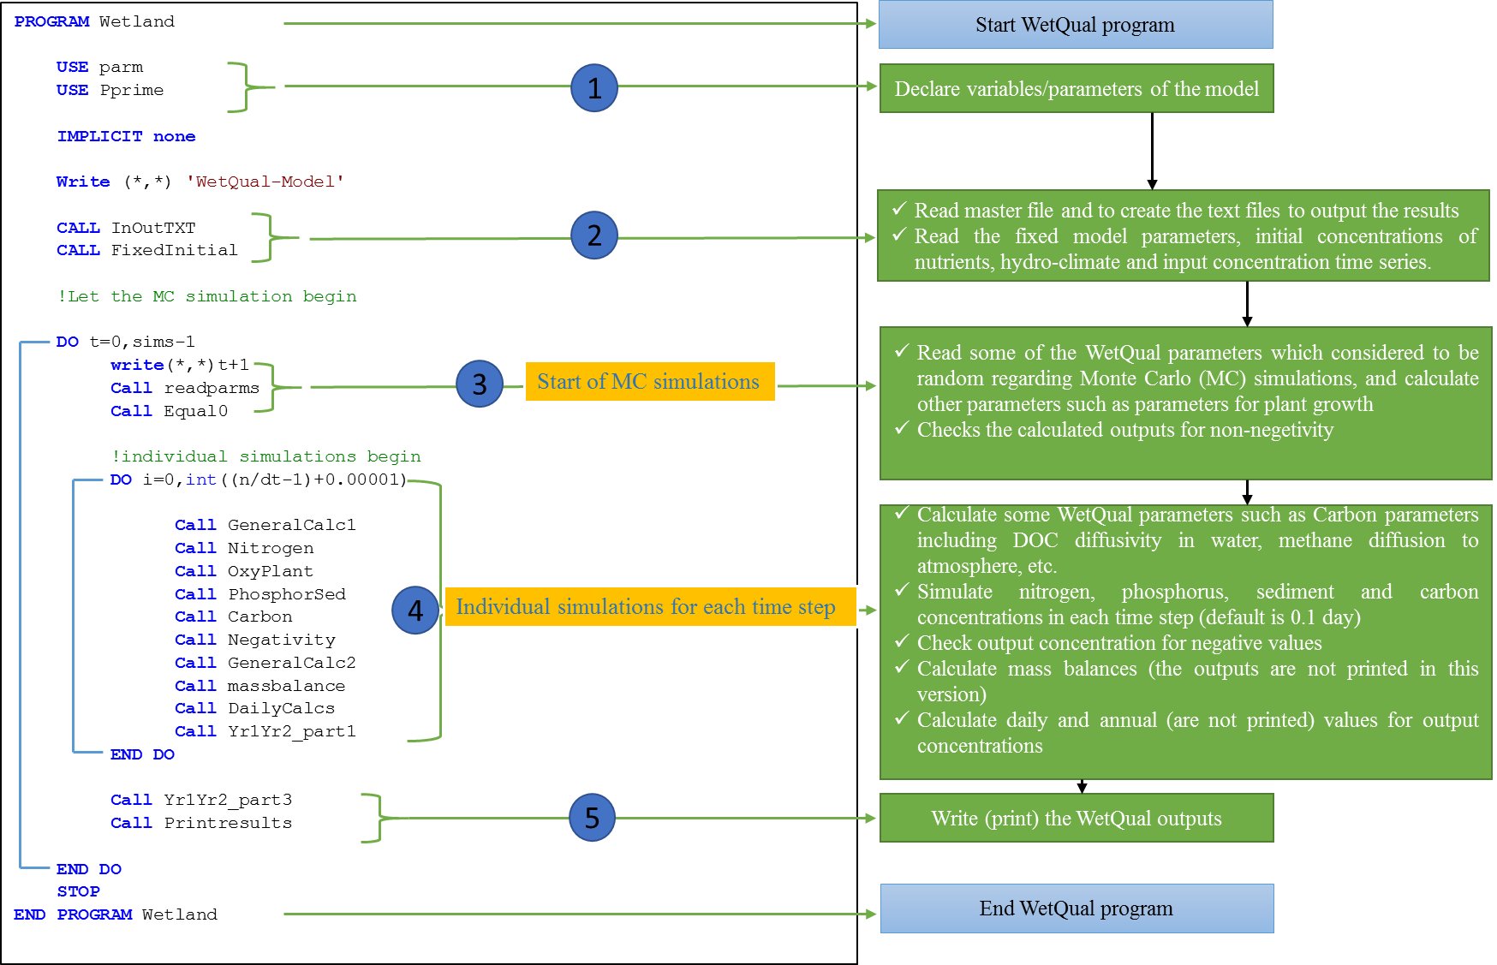

Figure A 1 A flowchart representing the internal structure and processes of *WetQual*